EYFS Forest School
Tuesday 23rd February
Signs of Spring
Can you name the four seasons?

I have started noticing more and more Spring flowers around. Have you noticed any? These are the ones I have spotted so far… can you name them?

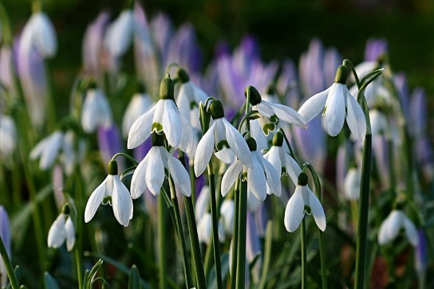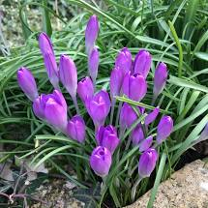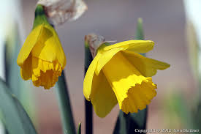
Snowdrop crocus daffodil

I love seeing them, they remind me that Spring is on its way – hurrah!

Today, will you go for a walk and see what signs of Spring you can spot?
Use the spotter sheet I have attached… Enjoy!

