EYFS Forest School
Tuesday 9th February
Did you enjoy using your senses to explore last week?
This week I have a few different ideas you may enjoy trying outside… (some of my favourites!) You could try them all or choose your favourite! Most importantly, enjoy being outside! I look forward to seeing what you get up to!

- Can you create a mini shelter/house/den with natural objects for your favourite toy?
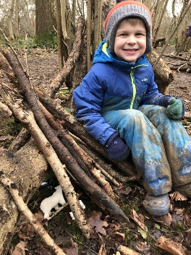
- Get four sticks and lay them on the floor as your “photo frame”. Can you make a picture inside using some natural materials? (It doesn’t have to be as big as the one below!)
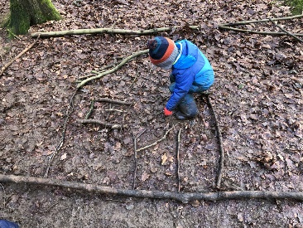
- Take some paper and crayons outside with you and try doing some natural rubbings.
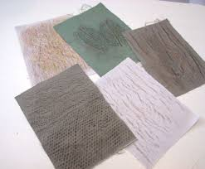
- As valentines Day is coming up, see if you can spot any love hearts in nature…!
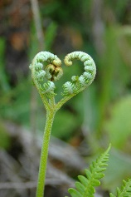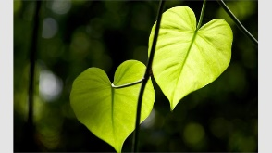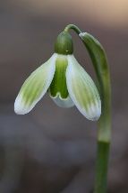

You can always do these at weekend or over half term if you are not able to do these today!

