Online Learning
Monday 1st February
Please upload what you have been up to onto Tapestry.

Chinese New Year
This week we are thinking about the special festival of Chinese New Year. I have uploaded a video onto Tapestry of me reading a story and chatting about Chinese New Year. I have uploaded a PowerPoint for you to look at too!
Can you write a sentence or two to tell Whizzy something about Chinese New Year?
(Encourage your child to be as independent as possible in their writing, writing the sounds they hear in each word - it may be phonetically correct but not necessarily spelt correctly!)

Phonics
Today our sound is er. I have put a video of this phonics session onto Tapestry. You will need to have your whiteboard and whiteboard pen handy!

Handwriting
Use your handwriting book to practise writing the letter w. (It’s a simple rhyme to say as your child forms the letter – “down up, down up!”) Can you think of any words beginning with w?

Maths
This week in maths we are thinking about subtraction.
For this game you will need your number cards in a randomly shuffled pile, your whiteboard and pen and some edible counters (raisins or chocolate buttons!). Take a number card and count out the correct amount of your edible counters to match. Instruct your child to take away/subtract some (they eat the correct amount!) How many do you have left? Then together write as a number sentence on your board. For example, I chose 10 and take away/subtract (eat!) 3 so I write 10-3=7.

Reading
Choose a book from your home learning pack. (Please get in touch with us via Tapestry when you would like more books and we can arrange for you to drop back your current ones and collect some new ones!) I also recommend looking at Oxford Owl website. They are offering free Biff, Chip and Kipper eBooks. Go to www.oxfordowl.co.uk and click on login (as a student) and use the details below. Then click on Oxford Owl eBook Library and select your book.
Class or Student Username: apple tree class Password: Appletree

Optional Extras:
- PE at home! Go to https:real.jasmineactive.com/login and click on EYFS. Today, click on “Train” and explore the activities here!
- Make a Happy Chinese New Year card for someone! 
- Make some turnip cakes using this recipe…
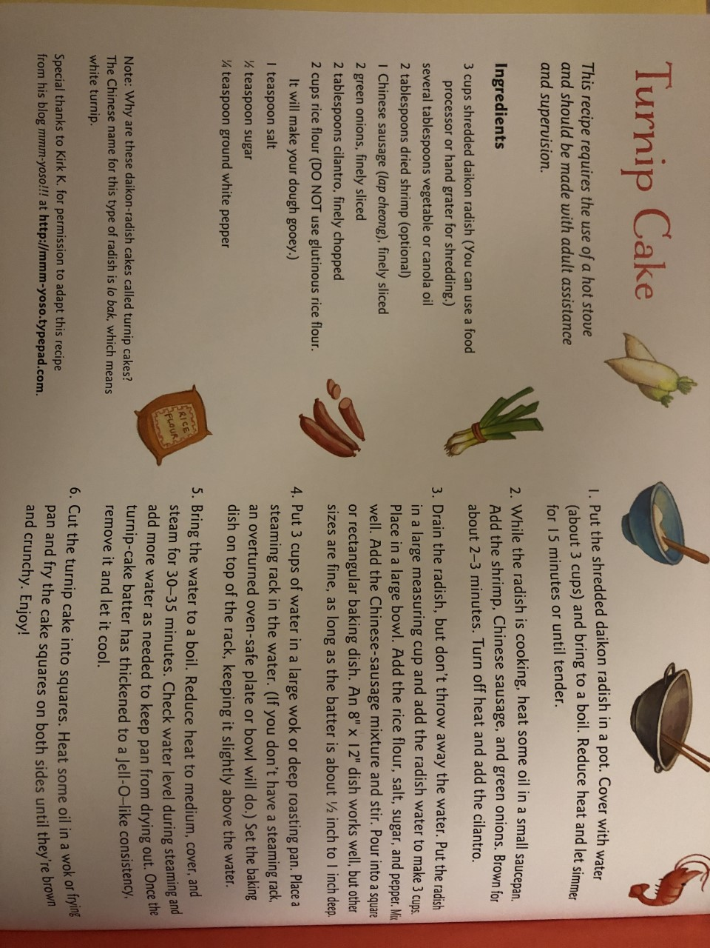

Nursery Children:
This week we are thinking about the special festival of Chinese New Year. I have uploaded a video onto Tapestry of me reading a story and chatting about Chinese New Year.
- Make some turnip cakes using the recipe above!
- Have a go at these Maths challenges:
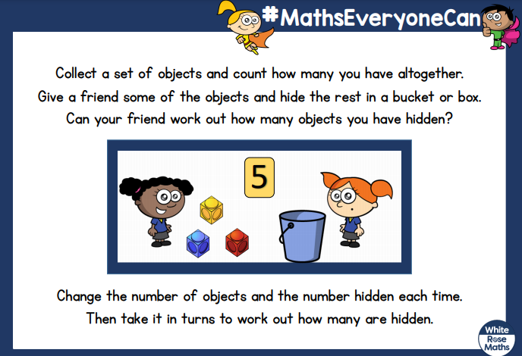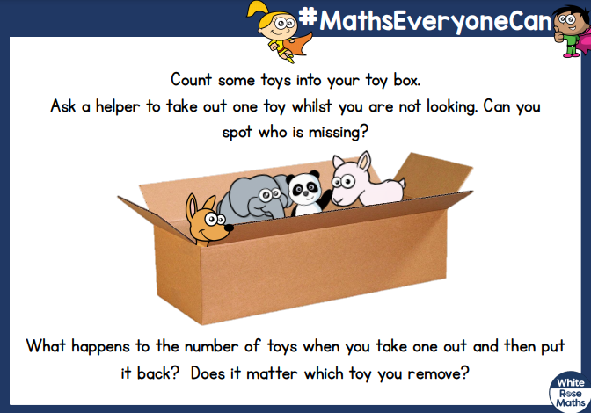
- PE at home! Go to https:real.jasmineactive.com/login and click on EYFS. Today, click on “Train” and explore the activities here!
- Make a Happy Chinese New Year card for someone, remember to write your name in it so they know who it is from!

