Online Learning
Thursday 4th February
Please upload your photos of your work and activities to Tapestry for us to comment on.
Our Topic is “China”. Here are today’s activities…

Writing/Topic
Watch this Lingo show about China.
https://youtu.be/TAmbw7u6DsM

Could you have a go at some Chinese writing?
I have attached some pictures to the website of some letters and numbers in Mandarin.

This Photo by Unknown Author is licensed under CC BY-SA
Phonics
Today our sound is ure. Have a look at the video on Tapestry.
Can you say the sound? Can you write the sound? Can you say/write some words or sentences with the sound in?
Handwriting
Use your handwriting book to practise writing the letter p. Can you think of any words beginning with p?

Maths
Try the game I have attached to the website involving lady birds, counters and a dice.

Reading
Choose a book from your home learning pack.

Optional Extra:
Learn some Mandarin to teach me.
Make fortune cookies real or pretend, I have provided a sheet with little sentences to cut up. Recipe provided below.
Make a Chinese sign with your writing, they generally use the colours red and gold



Fortune cookies
Save recipe
Love this recipe? Click save recipe to create an online cookbook

This recipe is:

- Christmas

- Snack

- Kid friendly

- Cooking with kids

- Baking
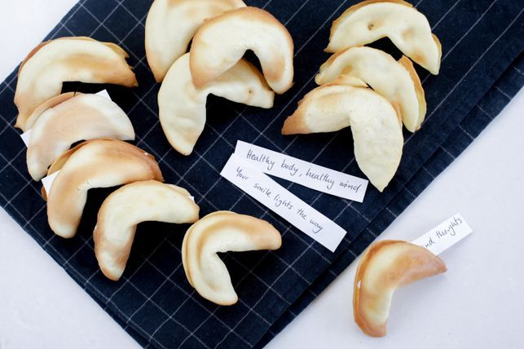
Try your hand at making these fortune cookies to celebrate Chinese New Year. They're easier to make then you might think, and you get to write your own fortunes to boot!

Ingredients
- 1 egg white
- 1/8 teaspoon vanilla extract
- 1 pinch salt
- 1/4 cup plain flour
- 2 tbsp caster sugar

Method
- 1
Write fortunes on small strips of paper and set aside.
- 2
Preheat oven to 180C. Cover two baking trays with baking paper.

KIDSPOT.COM.AU0:52

- 3
- Mix the egg white and vanilla until foamy but not stiff. Sift the flour, salt, and sugar and blend into the egg white mixture.
- 4
Place teaspoonfuls of the batter at least 10cm apart on one of the prepared trays. Tilt the tray to spread the cookie batter into round shapes about 7cm in diameter. Be careful to make batter as round and even as possible.
- 5
Do not make too many at once, because you will have to form the fortune cookie shape while they are hot - once the cookie begins to cool, it is too late to shape them. Start with 2 or 3 to a sheet and see how many you can do.
- 6
Bake for approx. 5 minutes or until cookie has turned a golden colour on its outer edge. The middle will remain pale. While one sheet is baking, prepare the other.
- 7
Remove baking tray from the oven and quickly remove a cookie with a well-greased, wide metal spatula. With gloves on, flip the cookie into your hand, lay the fortune across the middle of the cookie fold the cookie in half.
- 8
Using the edge of a glass, place the folded edge of the cookie across the edge and pull the pointed edges downwards until the unmistakeable shape of the fortune cookie is made.
- 9
Place the cookie into a muffin tray as it cools so that the shape is held until firm.

Nursery Children:
Today, Watch the clips see the optional activities above. Practise 1-1 counting with physical objects, learn to recognise your numbers to 10 and practise writing your name!

Have ago at this below.


