Online Learning
Wednesday 3rd February
Please upload your photos of your work and activities to Tapestry for us to comment on.
Our Topic is “China”. Here are today’s activities…

Writing/Topic
Watch these clips about China.
https://www.youtube.com/watch/iEueKKpWKAI
https://www.youtube.com/watch?v=FqZBIjKmls0
Can you write some facts about china either some thing you learnt from these clips or a fact you found out?
You could make a poster about China.
Say each word aloud, encouraging your child to write the sounds they hear (it may be phonetically correct but not necessarily spelt correctly!) Could you draw a picture to go with your fact?
“There are pink dolphins and pandas in China”

Phonics
Today our sound is air. Have a look at the video on Tapestry.
Can you say the sound? Can you write the sound? Can you say/write some words or sentences with the sound in?
Handwriting
Use your handwriting book to practise writing the letter k. Can you think of any words beginning with k?

Maths
Find the Chinese addition sheet attached to Website

Reading
Choose a book from your home learning pack.

Optional Extra:
Build the Great wall of China with blocks, Lego or similar.
Make Chinese dragons or masks
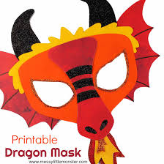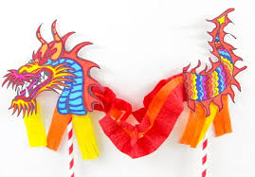


Nursery Children:
Today, Watch the clips see the optional activities above. Practise 1-1 counting with physical objects, learn to recognise your numbers to 10 and practise writing your name!

Have ago at this below.


