Online Learning
Monday 1st February
Please upload what you have been up to onto Tapestry.

China
Happy month everyone! We are launching a two week topic on China. This week we will be learning more about China and next week we will be finding out about Chinese New Year. I have uploaded a video onto Tapestry of me introducing the new topic to the children.
Can you find out about a famous building or landmark in China and write me a sentence(s) about it?
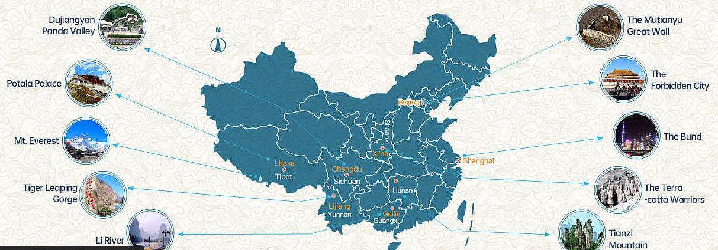
(Encourage your child to be as independent as possible in their writing, writing the sounds they hear in each word - it may be phonetically correct but not necessarily spelt correctly!)

Phonics
Today our sound is oi. I have put a video of this phonics session onto Tapestry. You will need to have your whiteboard and whiteboard pen handy!

Handwriting
Use your handwriting book to practise writing the letter h. (You may find this rhyme handy to say as your child forms the letter – (think of a horse) “down the head to his hooves and over his back”). Can you think of any words beginning with h?

Maths
This week in maths we are thinking about addition.
For this game you will need two dice and your whiteboard and pen. Roll the two dice, add them together and write as a number sentence on your board. For example, I roll and 5 and a 3 so I write 5+3=8.
You could add another layer to the game and have a sibling or a parent playing in turn to see who makes the biggest total after 5 rolls!

Reading
Choose a book from your home learning pack. (Please get in touch with us via Tapestry when you would like more books and we can arrange for you to drop back your current ones and collect some new ones!) I also recommend looking at Oxford Owl website. They are offering free Biff, Chip and Kipper eBooks. Go to www.oxfordowl.co.uk and click on login (as a student) and use the details below. Then click on Oxford Owl eBook Library and select your book.
Class or Student Username: apple tree class Password: Appletree

PSHRE
(personal, social, health, relationships education)
Our Key this half term is Share More which is all about connection, teamwork and communication. Today we will be doing our PSHRE live together on our Google Meet at 2.30-2.45pm thinking about treating others the way we want to be treated.
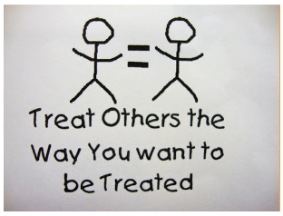
Click the link and “join meeting” at 2.30pm: meet.google.com/kst-xuoi-fkh
Hope to see you there!
(Nursery children, the details for yours are below!)

Optional Extras:
- Can you make the Chinese flag? 
- We use a wonderful scheme called Real PE at school and you can now use this platform at home! By now you should have been emailed your own username and password to access the site. Go to https:real.jasmineactive.com/login and click on EYFS. Today, click on “Tightrope” and explore the activities here!

Nursery Children:
Happy month everyone! We are launching a two week topic on China. This week we will be learning more about China and next week we will be finding out about Chinese New Year. I have uploaded a video onto Tapestry of me introducing the new topic to the children. Have a go at some of the activity ideas below:
- Have a look at some photos of China together! (I have uploaded some onto the website)
- Can you make the Chinese flag? Don’t forget to write your name on the back!
- Have a go at this Maths challenge:
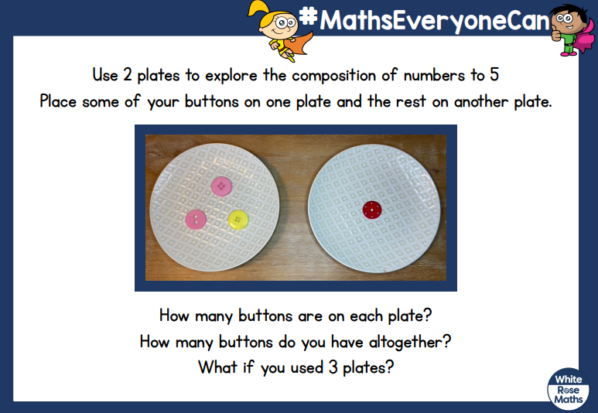
- Why not make some playdough to enjoy (you can find a recipe here: https://www.bbcgoodfood.com/howto/guide/playdough-recipe )
- We use a wonderful scheme called Real PE at school and you can now use this platform at home! By now you should have been emailed your own username and password to access the site. Go to https:real.jasmineactive.com/login and click on EYFS. Today, click on “Tightrope” and explore the activities here!
I have also arranged a Google Meet for Nursery children today at 3pm-3.15pm. Click the link and “join meeting” at 3.00pm: meet.google.com/vdw-nvtg-tow Hope to see you there!

