Online Learning
Wednesday 26th January
Please upload your photos of your work and activities to Tapestry for us to comment on.
Our Topic is one of my absolute favourites, “Once Upon a Time”. Here are today’s activities…

Today’s story is The Rainbow Fish, have a look at the video on Tapestry.
Phonics
Today our sound is ur. Have a look at the video on Tapestry.
Can you say the sound? Can you write the sound? Can you say/write some words or sentences with the sound in?
Writing/Handwriting
Use your handwriting book to practise writing the letter r. Can you think of any words beginning with r?
Have a go at writing some sentences about the story it could be what happened in the story or about the characters or the bit you enjoyed most. Encourage your child to think of a sentence e.g., “I liked the Rainbow fish’s beautiful colours and shiny fins best”. Then, say each word aloud, encouraging your child to write the sounds they hear (it may be phonetically correct but not necessarily spelt correctly!) Could you draw a picture to go with your story?
(Why not start your own book with each piece of writing your child completes about the different stories in our Once Upon a Time topic!)
Maths
Can you continue to talk about 2D shapes.
Describe a shape to your child and get them to guess what shape it is.
E.g., I have a shape with 4 sides the same length and 4 vertices.
What is it?

Reading
Choose a book from your home learning pack.

Optional Extra:
Rainbow fish art
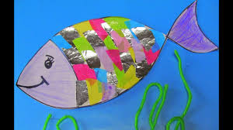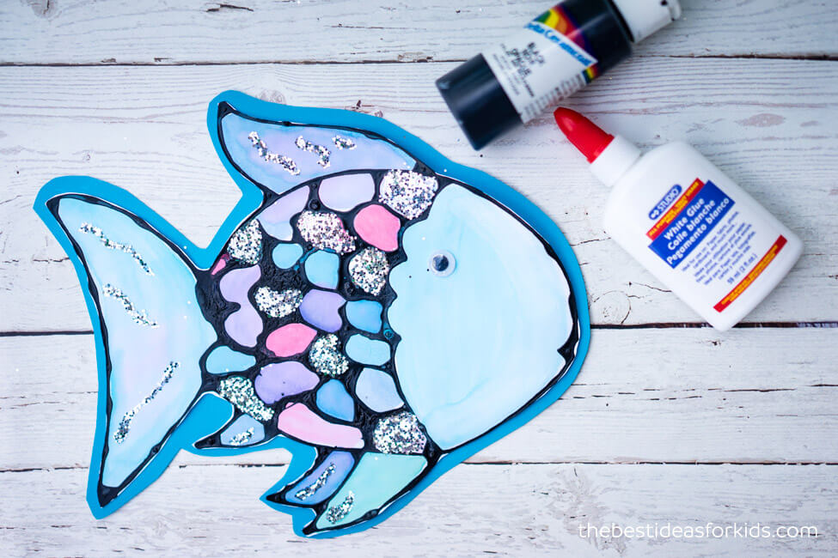

Nursery Children:
Today, listen to the story and see the optional activities above. Practise 1-1 counting with physical objects, learn to recognise your numbers to 10 and practise writing your name!
Practise your 2D shapes.

