Online Learning
Monday 25th January
Please upload what you have been up to onto Tapestry.

Once Upon a Time
This week we are looking at our favourite stories. Today’s story is my favourite, “Worrysaurus” By Rachel Bright. I hope you enjoy it - have a look at the video of me reading this on Tapestry.
I would love to hear about your favourite story. What is it called? What is it about? Will you write a sentence(s) telling me about your favourite book?
(Encourage your child to be as independent as possible in their writing, writing the sounds they hear in each word - it may be phonetically correct but not necessarily spelt correctly!)

Phonics
Today our sound is oo. I have put a video of this phonics session onto Tapestry. You will need to have your whiteboard and whiteboard pen handy!

Handwriting
Use your handwriting book to practise writing the letter y. (You may find this rhyme handy to say as your child forms the letter – (think of a yak) “down a horn, up a horn, under his head”). Can you think of any words beginning with y?

Maths
This week in maths we are thinking about 2D shapes and describing these shapes.
We would like ALL children to be able to name and describe a square, circle, rectangle and triangle. SOME children will also be able to name and describe a pentagon, hexagon, octagon and oval.
Look at the 2D shape game I have uploaded. See if you can guess what shape is hiding each time! The important question for today is “how do you know it is a square etc..?” We are looking for children to respond “It has four equal sides!” etc. It is worth noting that while a circle has no corners it does have one side that goes all the way around!
Now, my challenge is can you create some 2D shapes using lolly sticks or string? Think about how many sides each one will need!
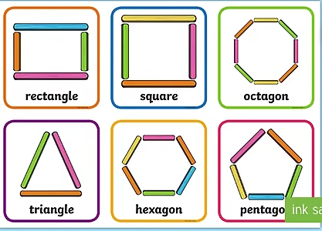

Reading
Choose a book from your home learning pack. (Please get in touch with us via Tapestry when you would like more books and we can arrange for you to drop back your current ones and collect some new ones!) I also recommend looking at Oxford Owl website. They are offering free Biff, Chip and Kipper eBooks. Go to www.oxfordowl.co.uk and click on login (as a student) and use the details below. Then click on Oxford Owl eBook Library and select your book.
Class or Student Username: apple tree class Password: Appletree

PSHRE
(personal, social, health, relationships education)
Our Key this half term is Share More which is all about connection, teamwork and communication. Today we will be doing our PSHRE live together on our Google Meet together at 2.30-2.45pm. I really hope that this works for everyone this time!! Click the link and “join meeting” at 2.30pm: meet.google.com/osb-kxuc-gwq Hope to see you there! (Nursery children, the details for yours are below!)

Optional Extras:
- Could you draw or paint the main character from your favourite story? You may even like to act out a part of your favourite story!
- We use a wonderful scheme called Real PE at school and you can now use this platform at home! By now you should have been emailed your own username and password to access the site. Go to https:real.jasmineactive.com/login and click on EYFS. Today, click on “Tightrope” and explore the activities here!
- Enjoy the 2D shape colouring I have attached

Nursery Children:
This week we are looking at our favourite stories. Today’s story is my favourite, “Worrysaurus” By Rachel Bright. I hope you enjoy it - have a look at the video of me reading this on Tapestry.
Have a go at some of the activity ideas below:
- Go on a 2D shape hunt… can you find a circle, triangle, square and rectangle? You may like to colour one of the 2D shape pictures I have attached.
- Could you tell me about your favourite story in a video? What is it about? Who are the characters in the story? Why do you like it?
- Can you draw me a picture of the main character in your favourite story? Don’t forget to write your name on your picture!
- We use a wonderful scheme called Real PE at school and you can now use this platform at home! By now you should have been emailed your own username and password to access the site. Go to https:real.jasmineactive.com/login and click on EYFS. Today, click on “Tightrope” and explore the activities here!
I have also arranged a Google Meet for Nursery children today at 3pm-3.15pm. Click the link and “join meeting” at 3.00pm: meet.google.com/sma-shjf-cjz Hope to see you there!

