Online Learning
Thursday 21st January
Please upload your photos of your work and activities to Tapestry for us to comment on.
Our Topic is one of my absolute favourites, “Once Upon a Time”. Here are today’s activities…

Today’s story is The Prodigal Son, have a look at the video on Tapestry.
Phonics
Today our sound is oa. Have a look at the video on Tapestry.
Can you say the sound? Can you write the sound? Can you say/write some words or sentences with the sound in?
Writing/Handwriting
Use your handwriting book to practise writing the letter t. Can you think of any words beginning with t?
Have a go at writing some sentences about something or someone makes you happy. Encourage your child to think of a sentence e.g., “I feel happy when I help others”. Then, say each word aloud, encouraging your child to write the sounds they hear (it may be phonetically correct but not necessarily spelt correctly!) Could you draw a picture to go with your writing?
(Why not start your own book with each piece of writing your child completes about the different stories in our Once Upon a Time topic!)
Maths
Have a look at the capacity sheet below.

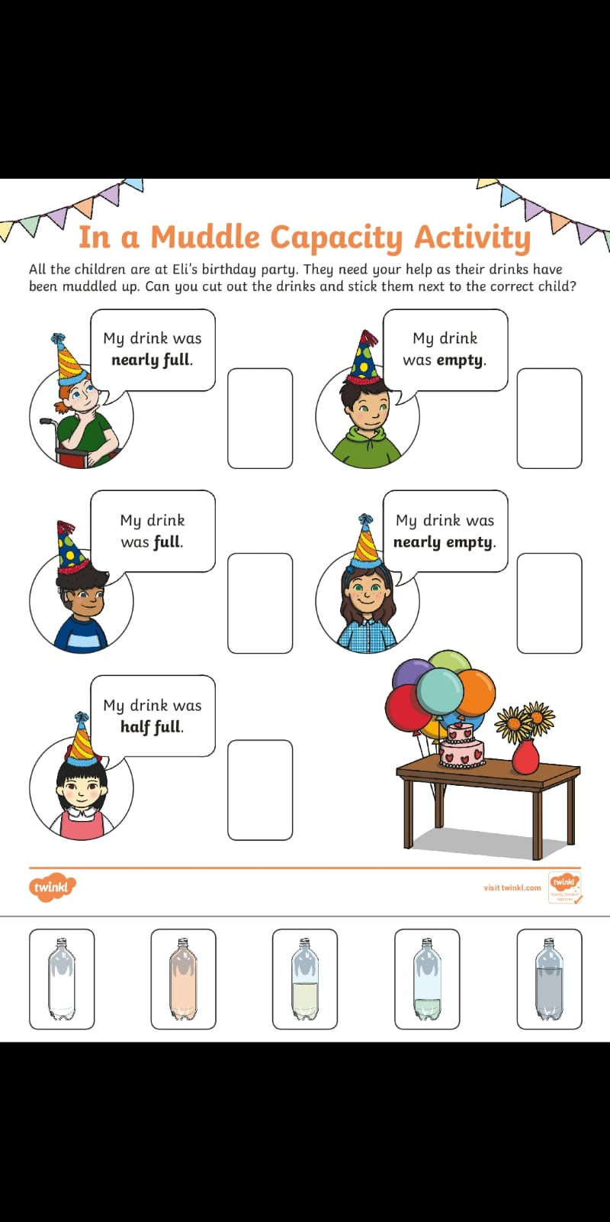

Reading
Choose a book from your home learning pack.

Optional Extra:
Can you go for a hunt in the garden or house and find something that makes you happy? Take a picture and send to me.
Can you draw or paint a picture of your family?

Play the memory game with a tray and 3 or 4 items, cover with a tea towel after your child has had a look at the items. Remove an item and uncover, see if your child knows what is missing.
Make cakes using cups to measure.

Nursery Children:
Today, listen to the story and see the optional activities above. Practise 1-1 counting with physical objects, learn to recognise your numbers to 10 and practise writing your name!
Practise your 2D shapes.

