KS2 History KCV – The Vikings in Anglo-Saxon Britain
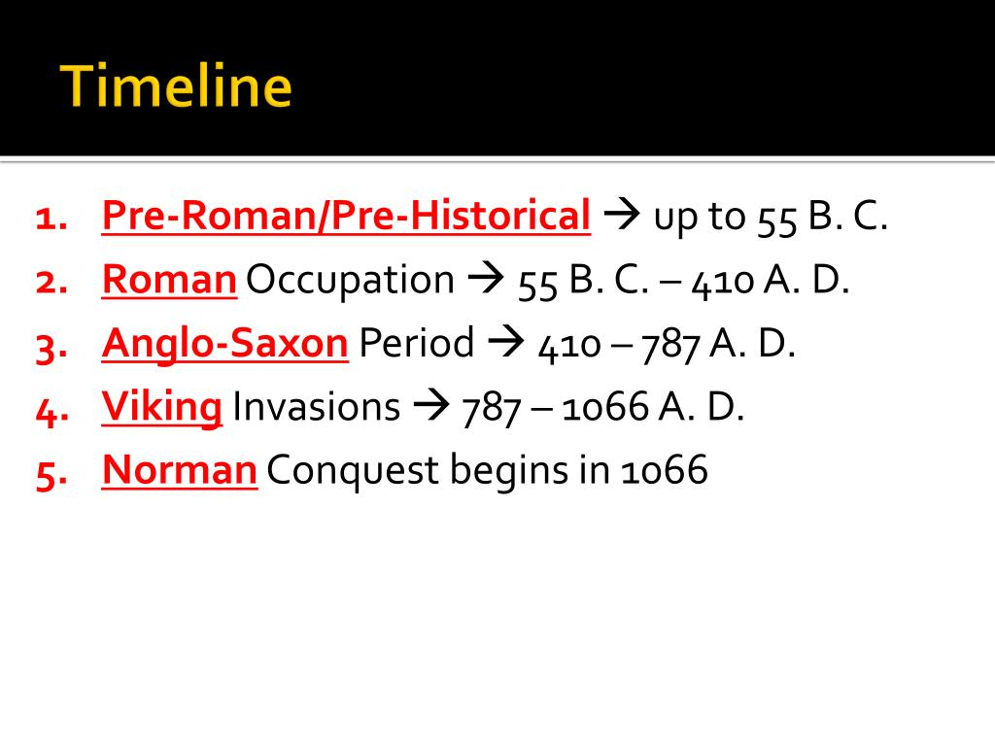

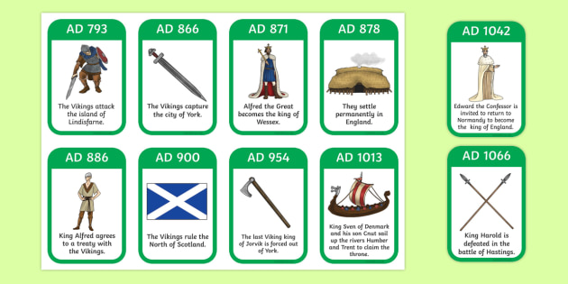

27 BC Augustus becomes the first Roman Emperor

High Frequency Vocabulary (Tier 2)
Resist | Military | Britain
Conquer | Rebellion | Europe
Compare | Describe | Evaluate
Explain | Temple

Key Concept Questions
How did the Vikings have shape British culture and history?
What was the impact of Anglo-Saxon Kings? How did their actions shape British history?
How is the modern day justice system similar or different with the Anglo-Saxon system?

Subject Specific Vocabulary (Tier 3)
Viking | Scandinavian seafaring pirates and traders who raided and settled in many parts of north-western Europe in the 8th–11th centuries.
Anglo-Saxon | Germanic inhabitants of England from their arrival in the 5th century up to the Norman Conquest.
Invasion | Forcefully taking over another country
Kingdom | A country, state, or territory ruled by a king or queen
Scandinavia | Scandinavia is a group of countries in northern Europe that includes Denmark, Norway and Sweden
Norse | Relating to ancient or medieval Norway or Scandinavia.
Saga | An historical tale of the first families who lived in Norway or Iceland.
Runes | A letter of an ancient Germanic alphabet
Danegeld | A tax paid to the Vikings to stop further blood-shed/invasions
Wergild | The value set in Anglo-Saxon and Germanic law upon human life in accordance with rank and paid as compensation to the kindred or lord of a slain person



