KS2 Science KCV – Forces
Key Knowledge | Detail
Identify the effect of gravity on objects falling to Earth. | Weight, motion, force, gravity.
Explore how forces are represented using force diagrams | Direction, force arrows, upthrust, balanced and unbalanced.
Investigate the different types of friction including air and water resistance. | Air resistance, water resistance and opposing motion.
Investigate the effects of adding pulleys and levers when moving objects. | Lever, fulcrum, magnitude.

Key Vocabulary
Gravity | The force that pulls two objects with mass towards each other. Gravity pulls us towards the earth.
Water resistance | This force acts between an object and water e.g. a boat on the sea. It is a type of friction
Air resistance | This force acts on an object moving through air. E.g. a plane, walking – just about anything!
Friction | This is a contact force which tries to stop objects moving.
Accelerate | This means to get faster.
Decelerate | This means to get slower.
Pulley | A type of wheel that is used to make lifting an object easier.
Gear | A toothed wheel used to change the speed an action happens.
Lever | Usually a straight bar that increases the amount of force you can apply. It rotates around a pivot.
Weight | Weight is a force with which objects are pulled towards downwards towards Earth.
Mass | An object has a mass, which is the total amount of material it is made of. Mass is not a force and is measured in kilograms.
Newton | The unit we measure forces in.

Key concept questions
Why do objects fall to Earth?
Is gravity the same everywhere?
How do we show the effect of forces?
Why is friction important?
How does a lever make a job easier?
Hoe does a pulley work?

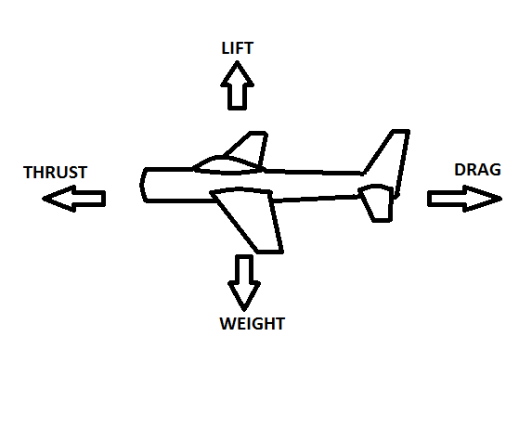

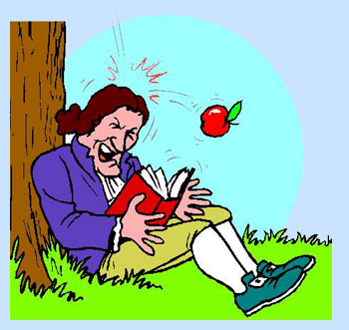
High Frequency Vocabulary (Tier 2)
Force | weight | unbalanced
Gravity | mass
Friction | balanced

