PSHRE
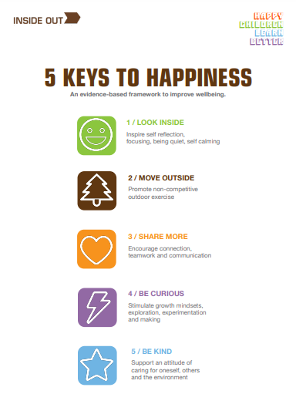
Personal, Social, Health and Relationships Education
As you may know, our PSHRE curriculum here at St Peter’s is based around the resources that Inside Out have designed. Just like we need 5 fruit and vegetables to maintain our physical health, we need the 5 Keys to maintain our mental health (www.theinsideout.org.uk ). Each term we focus on a different Key. In addition to our lessons around our Key we will also have lessons throughout the year that focus on something specific, for example internet safety. Please see below for what your child is doing this term in PSHRE…
PSHRE in Term 2
November and December 2023
This Term our focus key is Look inside, which inspires self-reflection, focus, being quiet and self-calming. We will think about different emotions and how to recognise these, knowing it is ok to feel every emotion. We will all experience each emotion at some point! We will think about behaviours we may demonstrate in response to these feelings and liken each feeling to a weather, to support us to describe how we feel. We will learn about self-care, the importance of it and some self-care strategies. It is important to ask for support to deal with emotions and feelings, when needed, so we will think about how we can ask for help and from whom.
This year Anti- bullying week will begin on Monday 13th November with the theme “make a noise about bullying.” We will start the week by joining in with odd socks day on Monday 13th November to show we are all unique and should be free to be ourselves. This is a fun and positive way to begin the week! We will then come together to discuss what we mean by bullying behaviour, how we can identify bullying and how we can make changes to reduce bullying.

