Welcome! Our first topic of this year is…
Superheroes
This is a wonderful topic celebrating a lot of different real life superheroes including ourselves, our families, communities and people that help us!
Milestone
Each topic includes a “Milestone Moment” that the children will experience. This topic the Milestone Moment links with the school value Aspiration and we will be having visits from inspirational people – more details to come! 😊
These Prime Areas (below) are fundamental to all we do. They will continue to be a priority each day through structured and incidental interactions. Please help your child learn how to put on their own shoes, socks and coats! 😊
Communication and Language  1. Listening, attention and Understanding, 2. Speaking |  | Personal, Social and Emotional Development  3. Self-regulation, 4. Managing self, 5. Building relationships |  | Physical Development  6. Gross Motor skills, 7. Fine motor skills
Literacy  8. Comprehension  9. Word reading  10. Writing  We are using some wonderful books throughout this topic, including “Would You Rather”, “Perfectly Norman”, “A Superpower Like Mine”, “A Superhero Like You”, “Supertato”, “The Family Book”. We are also excited to be starting “Drawing Club” which is about celebrating books, enriching children’s language, developing their fine motor skills and enjoying spending quality time together. Basically, we share a book, practise the key language and then get creative through drawing - all inspired by the book!  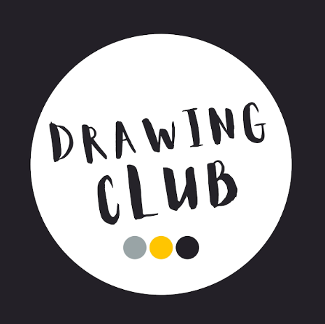 | Mathematics  11. Number  12. Numerical patterns  The Nursery children will be playfully exploring colour, through recognising different colours in their environments and naming these. They will then move onto sorting. Finding different ways to sort objects and understand the reasoning behind this.  Reception children will begin with sorting and pattern and then move onto looking at the composition of numbers to 5. |  | Understanding the World  13. Past and Present  14. People, Culture and Communities  15. The Natural World  We will be finding out about each other as valuable individuals - looks, interests, skills, hobbies. We will be finding out about our families and communities and showing an interest in different occupations. We will be exploring different factors that support our overall health and wellbeing, including looking after our teeth! |  | Expressive arts and design  16. Creating with materials  17. Being imaginative and expressive  We will be exploring the skills of collaging and painting throughout this term. This will allow children to learn and experiment with different ways to stick and layer materials together and enjoy some colour mixing- what new colours will they make!?  We will also have lots of opportunities for role playing, including a fire station, hospital and a home corner!
Key Vocabulary
unique, special, characteristics, different, skill, talent, a variety of describing words, pet, family, vet, teacher, librarian, dentist, teeth, decay, toothbrush, emergency, firefighter, police officer, doctor, paramedic, ambulance, help, thank you
Memos
- Please upload to Tapestry a photo of your child from the past – could be last month, last year or when they were born! Please also upload to Tapestry a family photo! We will be using these photos in some of our topical discussions! Thank you!
- Named water bottles and book bags to come into school every day please! Please only provide water in their bottles
- PE will be on a Tuesday afternoon - children to come to school in their PE kits and trainers on this day (please ask if you’re not sure what they should wear!)
- Forest School will be on a Wednesday afternoon. Children will need to bring their Forest School kit in a bag and we will help them change after lunch. Long sleeves, long trousers and waterproof trousers are always needed!

