Our topics this term are…
The Very Hungry Caterpillar and Sizzling Summer
We will begin this term by looking at The very hungry caterpillar and how we can care for ourselves and our natural world before moving onto summer and discussing holidays and how to care for ourselves in summer.

Milestone
Each topic includes a “Milestone Moment” that the children will experience, linked to our school values. This term we are focussing on: The value of COMPASSION, where we will care for caterpillars and watch them grow into beautiful butterflies – before releasing them into the natural beauty of our world!
The value of GENEROSITY, where we will bake biscuits and take them to the care home along with our butterfly artwork.
These Prime Areas (below) are fundamental to all we do. They will continue to be a priority each day through structured and incidental interactions. Please can you help us at home by helping your child learn how to put on their own shoes, socks and coats!
Communication and Language  1. Listening, attention and Understanding, 2. Speaking |  | Personal, Social and Emotional Development  3. Self-regulation, 4. Managing self, 5. Building relationships |  | Physical Development  6. Gross Motor skills, 7. Fine motor skills
Literacy  8. Comprehension  9. Word reading  10. Writing  We will be starting our topic by reading The Very Hungry Caterpillar and reading other books around insects like The Crunchy, munchy caterpillar before moving onto Olivers milkshake and Oliver’s fruit salad.  We will continue our daily phonics activities. Nursery will be focussing on oral segmenting and blending. Identifying what sounds are in words and how to blend these together.  We will be meeting Fred (the RWI frog) and using ‘Fred talk’ to play games in preparation for phonics next year!  Reception will continue their Read Write Inc sessions, look at their reading dairies to find out more information! | Mathematics  11. Number  12. Numerical patterns  Reception will be continuing to learn about numbers to 20 and extend on their already brilliant knowledge within 20. They will also look at shape, space and measure.  Nursery will be focussing on weight, capacity and positional language. Lots of practical exploration around weight and capacity as well as finding and hiding objects around the environment to find using positional language! |  | Understanding the World  13. Past and Present  14. People, Culture and Communities  15. The Natural World  This term we will look at Life cycles, in particular that of the caterpillar. We will care of and watch our very own caterpillars turn into butterflies, before releasing them.  We will continue to look at our natural world and how to care for the environment, including the Ocean.  We will also think about how to care for ourselves, regarding healthy eating, oral health and how to stay safe in the sun.  Everyone will get the opportunity to make their own fruit salad or milkshake, just like Oliver, in the stories! |  | Expressive arts and design  16. Creating with materials  17. Being imaginative and expressive  We will focus on American artist, Eric Carle this term and will be looking particularly at his collage work. We will make our own colourful butterflies, using the folding technique and will create lots of our own insects and minibeasts using various materials.  Children will have the opportunity to explore a Fruit and veg shop play at the beginning of the term before turning it into a beach cafe role play.  We will continue to use “Tales toolkit” to be imaginative and create our own stories! Please do look out on Tapestry and during ‘stop and see’ for your child’s group story.
Key Vocabulary
Life cycle, caterpillar, chrysalis, butterfly, egg, minibeast, habitat, healthy, insects, spiders, snails, woodlice, worms, millepedes, centipedes, healthy, fruit, vegetables, body, diet, sugar, teeth, decay, toothbrush

Season, weather, daylight, sun, shade, hat, sunscreen, summer, holiday, beach, sea, seaside
Memos
- PE will be each Tuesday afternoon. Please send children to school in their PE kits, they can wear these all day on a Tuesday.
- Forest School will continue to be each Wednesday afternoon (please send Forest School waterproofs/clothes in a bag and we will help children to change for their session at lunchtime).
- Sports Day is Tuesday 6th June 2-3pm – We can’t wait for you to join us for this!
- We have our “Stop and See” session the LAST Wednesday of term 3.00-3.10 for you to pop in and see what’s going on inside Apple Tree Class!
- Please help us spread the word about our Stay and Play sessions, open to those with children 0-4years, by inviting any neighbours, family or friends with children in this age group. £3 per family. Next session is: 20th June 2-3pm – we hope to see you there!
- Our class trip to the Cotswold Wildlife Park is Monday 17th July – permission letters will be coming out soon!

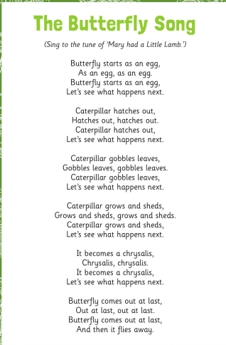
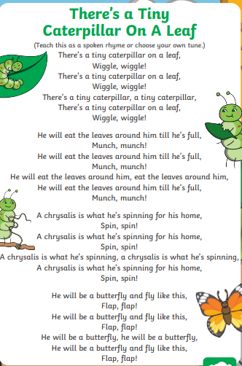
Topical Songs


