PSHRE
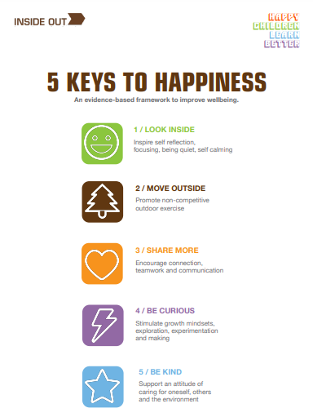
Personal, Social, Health and Relationships Education
As you may know, our PSHRE curriculum here at St Peter’s is based around the resources that Inside Out have designed. Just like we need 5 fruit and vegetables to maintain our physical health, we need the 5 Keys to maintain our mental health (www.theinsideout.org.uk ). Each term we focus on a different Key. In addition to our lessons around our Key we will also have lessons throughout the year that focus on something specific, for example internet safety. Please see below for what your child is doing this term in PSHRE…
PSHRE in Term 6
June and July 2023

This Term our focus key is Be Kind, which is all about supporting an attitude of caring for oneself, others and the environment. We will be recapping the meaning of Respect and Kindness and discussing how we show these and can be kind to others. We will look at our own health and how to protect this, especially through healthy eating, rest and sleep. There will be discussions around what is a healthy food and thinking about what would happen if we only ate unhealthy foods. We will think about some mindfulness techniques to help us sleep and think about our own bedtime routines, e.g. reading a story before bed. We will finish ‘Be Kind’ by discussing and thinking of the benefits of being kinds to others. We will think about times we have helped people, both in school and the community, and what positive qualities we have.

