PSHRE
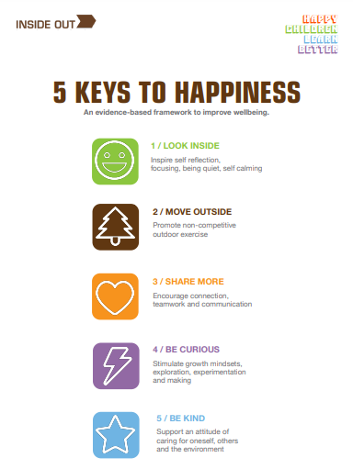
Personal, Social, Health and Relationships Education
As you may know, our PSHRE curriculum here at St Peter’s is based around the resources that Inside Out have designed. Just like we need 5 fruit and vegetables to maintain our physical health, we need the 5 Keys to maintain our mental health (www.theinsideout.org.uk ). Each term we focus on a different Key. In addition to our lessons around our Key we will also have lessons throughout the year that focus on something specific, for example internet safety. Please see below for what your child is doing this term in PSHRE…
PSHRE in Term 5
April and May 2023

This Term our focus key is Be Curious, which is all about encouraging a growth mindset, about exploration and experimentation. We will be looking at the importance of self-care, in order to care for our mental health and wellbeing. This will include hobbies and interests and the benefit of these. We will explore the feelings of loneliness and sadness, how to identify those, talking about our weather inside (from our look inside key) and how we can overcome these feelings. Together we will think about what we could do if we are feeling bored, like reading a story or participating in their hobby/interest. We will challenge stereotypes and talk about us all as an individual and our right to express our self, as long as it doesn’t take someone else’s freedom or break any rules. This key will hopefully instil curiosity into everyone and encourage them to have a go, even if it is something new!

