Welcome! Our next topic of this year is…
Celebrations
This is a wonderful topic celebrating some different celebrations and festivals!

Milestone
Each topic includes a “Milestone Moment” that the children will experience which links to one of the school values. This topic they are:

Courage: take part in a performance, inviting parents/carers to watch. Visit the theatre to watch a performance.
Peace: Visit St Peter’s church to find out why Christmas is a special time for Christians.

These Prime Areas (below) are fundamental to all we do. They will continue to be a priority each day through structured and incidental interactions. Please help your child learn how to put on their own shoes, socks and coats! 😊
Communication and Language  1. Listening, attention and Understanding, 2. Speaking |  | Personal, Social and Emotional Development  3. Self-regulation, 4. Managing self, 5. Building relationships |  | Physical Development  6. Gross Motor skills, 7. Fine motor skills
Literacy  8. Comprehension  9. Word reading  10. Writing  We are using some wonderful books throughout this topic, including the following:  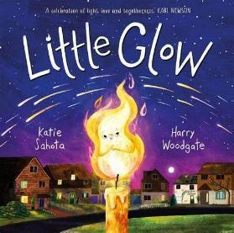  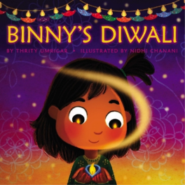  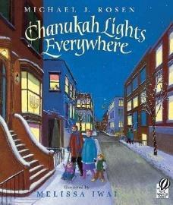  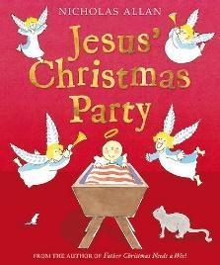  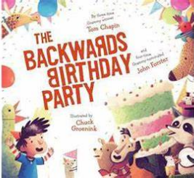  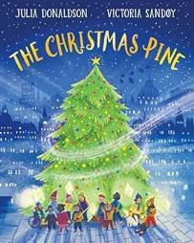  We’ll continue our drawing adventures at Drawing Club and our daily phonics sessions (lots of singing and word play for Nursery and Reception children will have a note in their reading diary each week about their phonics!) | Mathematics  11. Number  12. Numerical patterns  The Nursery children will be playfully exploring counting skills, subitising skills, patterns and matching.  The Reception children will be exploring the composition of numbers to five and the concept of ‘whole’ and ‘part’. They’ll also explore mass, capacity and shapes with four sides. |  | Understanding the World  13. Past and Present  14. People, Culture and Communities  15. The Natural World  We will be finding out about some of the different celebrations that different people may celebrate. We’ll be talking about bonfire night, Diwali, birthdays, Hanukkah and Christmas!  At Forest School we’ll be exploring the seasonal changes including talking about the weather, hibernation, migration and the daylight hours! |  | Expressive arts and design  16. Creating with materials  17. Being imaginative and expressive  This term we will be focussing on the skill of printing and looking at some of the art by artist Nat Morley. We’ll be learning lots of new songs in preparation for our nativity play. We will also be creating a post office role play nearer christmas time!
Key Vocabulary
celebration, Diwali, festival, Christmas, birthday, Hanukkah, Christian, Jesus, celebrate, party
Memos
- Please come along and watch our class nativity play on Tuesday 9th December at 1.45-3pm (if your child is not usually in on a Tuesday afternoon and you would like them to be involved, please book them in by speaking to Emily in the office!)
- Apple Tree have their first class trip to see Dear Father Christmas at the theatre on Tuesday 16th December (if your child is not usually in on a Tuesday morning and you would like them to join the trip please book them in by speaking to Emily in the office!)
- PE continues to be a Monday afternoon and Forest School a Wednesday afternoon

