PSHRE
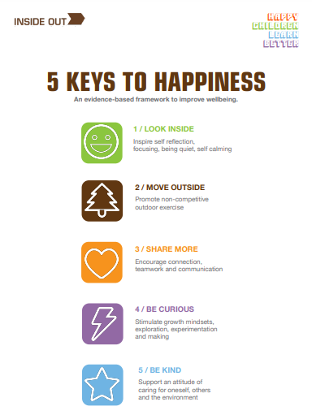
Personal, Social, Health and Relationships Education
As you may know, our PSHRE curriculum here at St Peter’s is based around the resources that Inside Out have designed. Just like we need 5 fruit and vegetables to maintain our physical health, we need the 5 Keys to maintain our mental health (www.theinsideout.org.uk ). Each term we focus on a different Key. In addition to our lessons around our Key we will also have lessons throughout the year that focus on something specific, for example internet safety. Please see below for what your child is doing this term in PSHRE…
PSHRE in Term 4
February and March 2023

This Term our focus key is Share More, which is all about encouraging connection, teamwork and communication. We will be thinking about Friendship and what a healthy friendship looks like, as well as families and discussing why Families are important, but also how disagreements may happen and how we can resolve these. We will think about Respect, how we can show respect to others, including the Rights of the child, so children can ensure they are treated with respect by others too. Children will discuss who they can go to for help and support, when needed, as well as looking at the importance of teamwork and how this can be beneficial.
We will also spend a week thinking about safety on the internet. During this week we will be looking at how and why we use the internet, thinking of some programmes and apps the children may use. We will discuss how we can keep ourselves safe whilst online and look at a story from Digi Duck.

