PSHRE
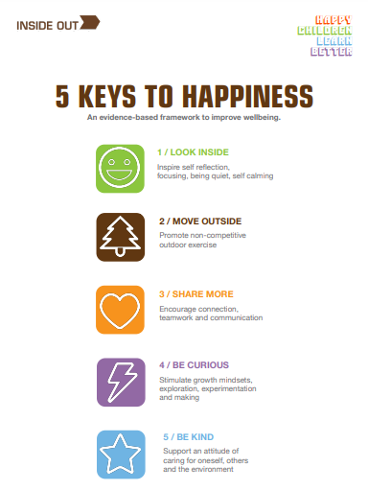
Personal, Social, Health and Relationships Education
As you may know, our PSHRE curriculum here at St Peter’s is based around the resources that Inside Out have designed. Just like we need 5 fruit and vegetables to maintain our physical health, we need the 5 Keys to maintain our mental health (www.theinsideout.org.uk ). Each term we focus on a different Key. In addition to our lessons around our Key we will also have lessons throughout the year that focus on something specific, for example internet safety. Please see below for what your child is doing this term in PSHRE…
PSHRE in Term 3
January and February 2023

This Term our focus key is Move Outside, which is all about promoting non-competitive outdoor exercise. We will be looking at different types of exercise, through outdoor games, and discussing how they make us feel. We will look at the benefits of exercise for both our physical and mental health, as well as exploring some mindfulness techniques.

We also have two stand alone weeks, the first (w/b 30th January) will be about basic first aid. During this week we will be learning about who we call in an emergency and how. The second (w/b 6th February) will be about safety on the internet and will coincide with Safer Internet Day on 7th February. During this week we will be thinking about what we use the internet for and how we can stay safe whilst online- with help from Smartie the Penguin.

