Our topic this term is…
The Very Hungry Caterpillar
We will be looking at The Very Hungry Caterpillar, healthy foods, lots of different minibeasts and how to care for the world around us.
Milestone
Each topic includes a “Milestone Moment” that the children will experience, linked to our school values. This term we are focussing on: The value of COMPASSION, where we will care for caterpillars and watch them grow into beautiful butterflies and then release them!
The value of GENEROSITY, where we will join the residents at Churchfields care home to share some butterfly activities together!
These Prime Areas (below) are fundamental to all we do. They will continue to be a priority each day through structured and incidental interactions. Please can you help us at home by helping your child learn how to put on their own shoes, socks and coats!
Communication and Language  1. Listening, attention and Understanding, 2. Speaking |  | Personal, Social and Emotional Development  3. Self-regulation, 4. Managing self, 5. Building relationships |  | Physical Development  6. Gross Motor skills, 7. Fine motor skills
Literacy  8. Comprehension  9. Word reading  10. Writing  We will be sharing the stories of The Very Hungry Caterpillar, The Crunchy Munchy Caterpillar, Mad About Minibeasts, Betsy Buglove Saves the Bees, Somebody Crunched Colin, Olivers Milkshake and Oliver’s Fruit Salad.  We will be doing lots of talking and writing around these stories, in addition to our daily phonics activities. | Mathematics  11. Number  12. Numerical patterns  Reception will be developing their confidence in exploring the composition of numbers to 10, knowing the numbers that go together to make 10. They will also look at shape, space and measure.  Nursery will be focussing on weight, capacity and positional language with lots of practical exploration. They will also be practising their subitising skills and playing lots of dice games. |  | Understanding the World  13. Past and Present  14. People, Culture and Communities  15. The Natural World  This term we will look at Life cycles, in particular that of the caterpillar. We will watch our very own caterpillars turn into butterflies, before releasing them.  We will be finding and learning about various minibeasts. We will look at how to care for our world and the creatures we find.  We will also think about healthy foods and make our own fruit kebabs and milkshakes, just like Oliver in our story! |  | Expressive arts and design  16. Creating with materials  17. Being imaginative and expressive  We will focus on the artis Eric Carle, looking at his collage work. We will make our own colourful butterflies, using the folding technique and will create lots of our own insects and minibeasts using various materials.  We will have lots of role play opportunities including a fruit and vegetable shop and a café!
Key Vocabulary
Life cycle, caterpillar, chrysalis, butterfly, egg, habitat, healthy diet, minibeast, insect, litter, pollution, protect.
Memos
- PE will continue to be on a Monday afternoon. Please send children to school in their PE kits as they can wear these all day on a Monday.
- Forest School/ Nature discovery will continue to be each Thursday afternoon (please send Forest School waterproofs/clothes in a bag and we will help children to change for their session at lunchtime). NO Forest School on Thursday 26th June
- Please help us spread the word about our Stay and Play sessions, open to those with children 0-4years, by inviting any neighbours, family or friends with children in this age group. £3 per family. Our next sessions are on Friday 13th June and Friday 11th July 2-3pm, we hope to see you there!
- Reception 2025-2026 parent induction meeting on Wednesday 4th June 315 – 345.
- There is a whole school transition afternoon on Thursday 26th June. There will be NO Forest School on this day!
- Apple Tree sports day will take place on Tues 2nd July at 930am. Please come and watch if you are able too
- Our end of year trip will be to the Cotswold Wildlife park on Wednesday 16th July. If you are able to support on this trip, please let us know, thank you.

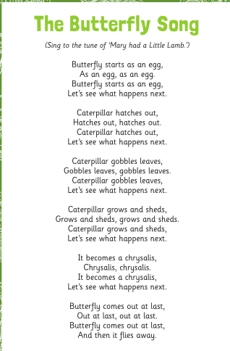
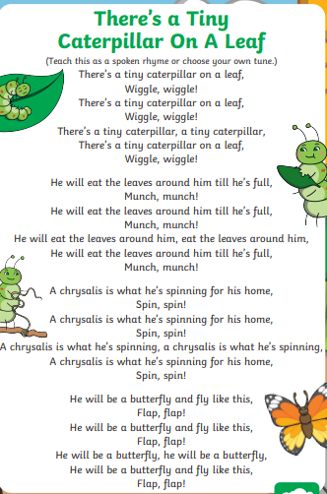
Topical Songs


