PSHRE
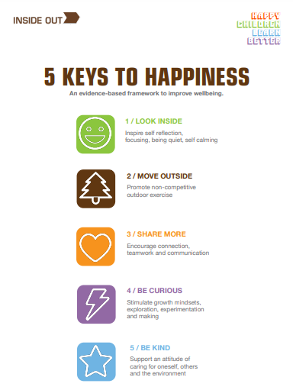
Personal, Social, Health and Relationships Education
As you may know, our PSHRE curriculum here at St Peter’s is based around the resources that Inside Out have designed. Just like we need 5 fruit and vegetables to maintain our physical health, we need the 5 Keys to maintain our mental health (www.theinsideout.org.uk ). Each term we focus on a different Key. In addition to our lessons around our Key we will also have lessons throughout the year that focus on something specific, for example internet safety. Please see below for what your child is doing this term in PSHRE…
PSHRE in Term 3
January and February 2025
This Term our focus key is Move Outside, which promotes non-competitive outdoor exercise. The children will look at physical health, alongside mental health, and understand what an active lifestyle is. They will think about the characteristics of an active lifestyle versus an inactive lifestyle and there will be opportunities to participate in activities outside and see how they make them feel afterwards! They will think about and discuss ways to build regular exercise into their own life, e.g. walking to school, discuss the benefits of exercise and spending time outside, as well as thinking about the equipment they may need to carry out these ideas, like appropriate clothing for the weather.
We will also have a standalone week at the end of the term to focus on First Aid week; where children will learn how to get help in an emergency!

