Our next topic is…
Colourful
This topic is full of art and craft opportunities and led by some wonderful texts exploring feelings, difference and uniqueness. It will lead us nicely into Autumn and exploring seasonal changes towards the end of this term.
Milestone
Each topic includes a “Milestone Moment” that the children will experience, linked to our school values. This term they are…
Creativity: Create rainbow art to be displayed and viewed by visitors. We will invite families in to complete rainbow craft activities together!
Generosity: Bake some treats to share.
These Prime Areas (below) are fundamental to all we do. They will continue to be a priority each day through structured and incidental interactions. Please can you help us at home by helping your child learn how to put on their own shoes, socks and coats!
Communication and Language  1. Listening, attention and Understanding, 2. Speaking |  | Personal, Social and Emotional Development  3. Self-regulation, 4. Managing self, 5. Building relationships |  | Physical Development  6. Gross Motor skills, 7. Fine motor skills
Literacy  8. Comprehension  9. Word reading  10. Writing  Our key texts will include…  Colour Monster  Mixed  Calm Down, Zebra  Elmer  The Smeds and the Smoos  Festival of colours  Little Acorn  Autumn poems  As well as lots of opportunities for exploring and discussing texts children will also take part in daily phonics sessions. | Mathematics  11. Number  12. Numerical patterns  Nursery children will be exploring colour, looking at the different ways they can sort objects and will begin to explore pattern.  Reception children will begin with sorting in various ways and then will look at patterns, before moving onto looking at the composition of numbers to 5. |  | Understanding the World  13. Past and Present  14. People, Culture and Communities  15. The Natural World  We will be learning about ourselves and each other, looking at our characteristics, skills and our likes and dislikes., developing positive attitudes about the differences between people.  We will be exploring the natural world, describing the seasonal changes we see, hear and feel whilst outside. We will talk about the life cycle of an Oak tree and learn about hibernation.  We will be discussing the theme of Harvest and talking about where our food comes from as well as looking at ‘festival of colours’ and thinking about different beliefs and celebrate special times in different ways. |  | Expressive arts and design  16. Creating with materials  17. Being imaginative and expressive  We will have lots of opportunities to explore colour and pattern, creating collages and mixing colours together to create new colours.  We will look at the British artist Norman Adams and his paintings of rainbows and create our own rainbow pictures.  We will also look at Dutch artist Piet Mondrian who mixed his own colours to paint pictures – we will have a go at creating our own square pictures!  We will be developing our drawing skills and imaginations through drawing club.  As always, we will be singing lots! We’ve attached some of our topical songs on the next page…
Key Vocabulary
hue, light, dark, indigo, violet, mixing, repeating pattern, emotion, angry, cross, worried, anxious, excited, love, different, unique, special
rainbow, colour, red, orange, yellow, green, blue, indigo, violet, mixing, repeating pattern, feeling, sad, happy, angry, worried, excited, love, different, special, Season, Autumn, leaves, colours, weather, seeds, acorns, oak tree, sapling, grow, hibernation, migration, celebration, fireworks, bonfire, harvest, church
Memos
- PE will be each Monday afternoon. Please send children in their PE kits, they can wear these all day on a Monday.
- Nature discovery/Forest School will be each Thursday afternoon (please send Forest School waterproofs/clothes in a bag and we will help children to change for their session at lunchtime)
- We may still get some lovely sunny days yet (fingers crossed!) so, please do send in a named sun hat and a named sun cream for us to keep in school and use on sunny days. When needed, we ask that you apply sun cream in the morning, and we will reapply at lunchtime!
- You are invited to join us for a rainbow craft session on Wednesday 18th September 2.15-3pm (We do understand that not everyone can attend due to work commitments)
- Please help us spread the word about our Stay and Play sessions, open to those with children 0-4years, by inviting any neighbours, family or friends with children in this age group. £3 per family. We will let you know our sessions as soon as we have finalised dates

Topical Songs

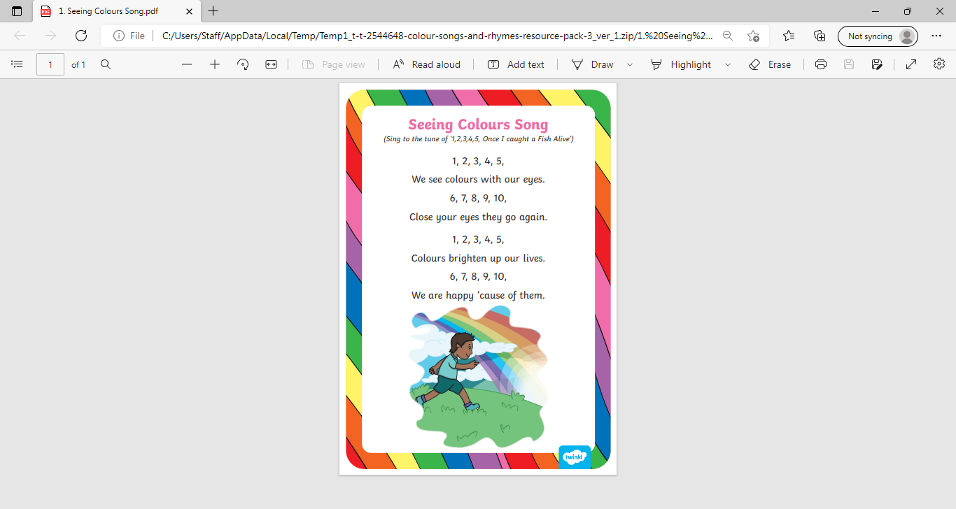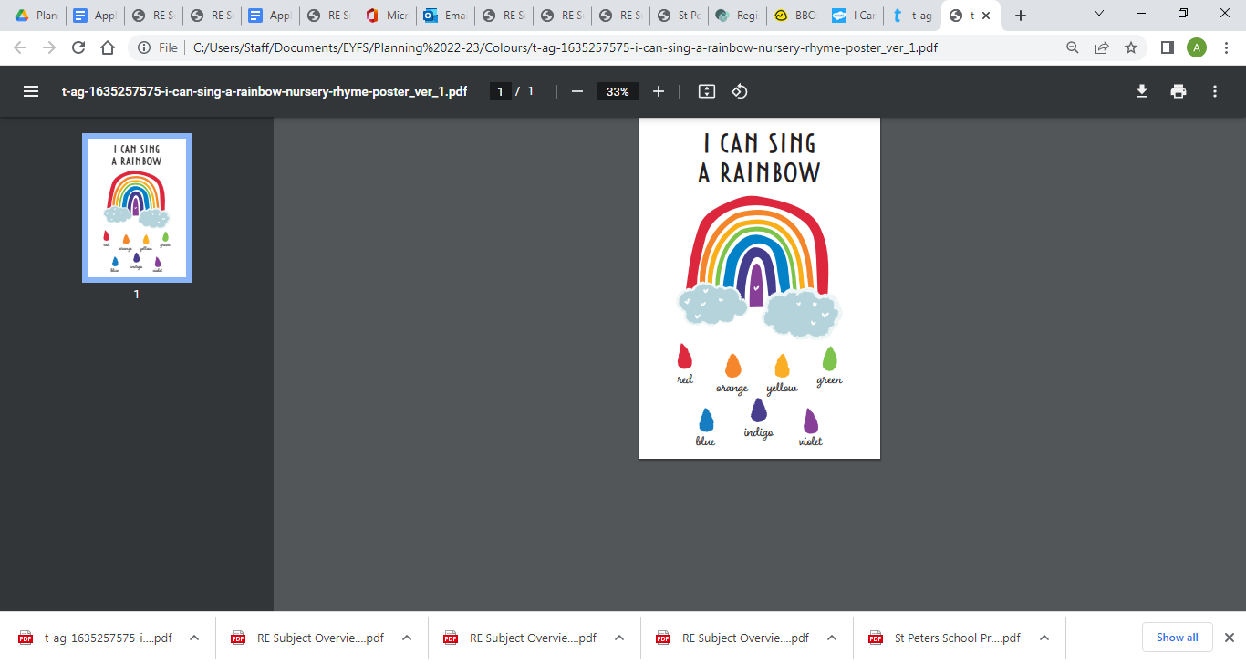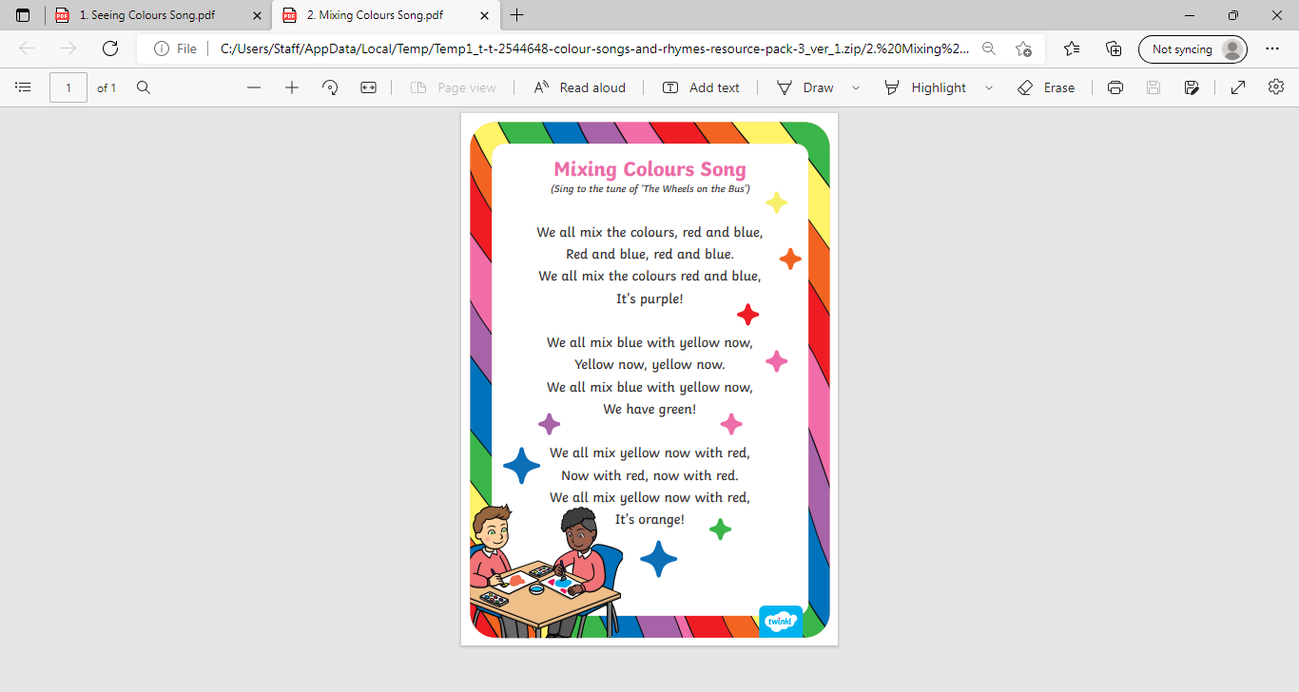
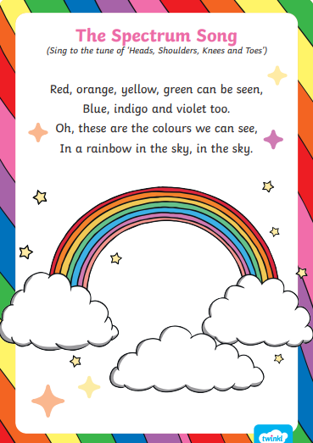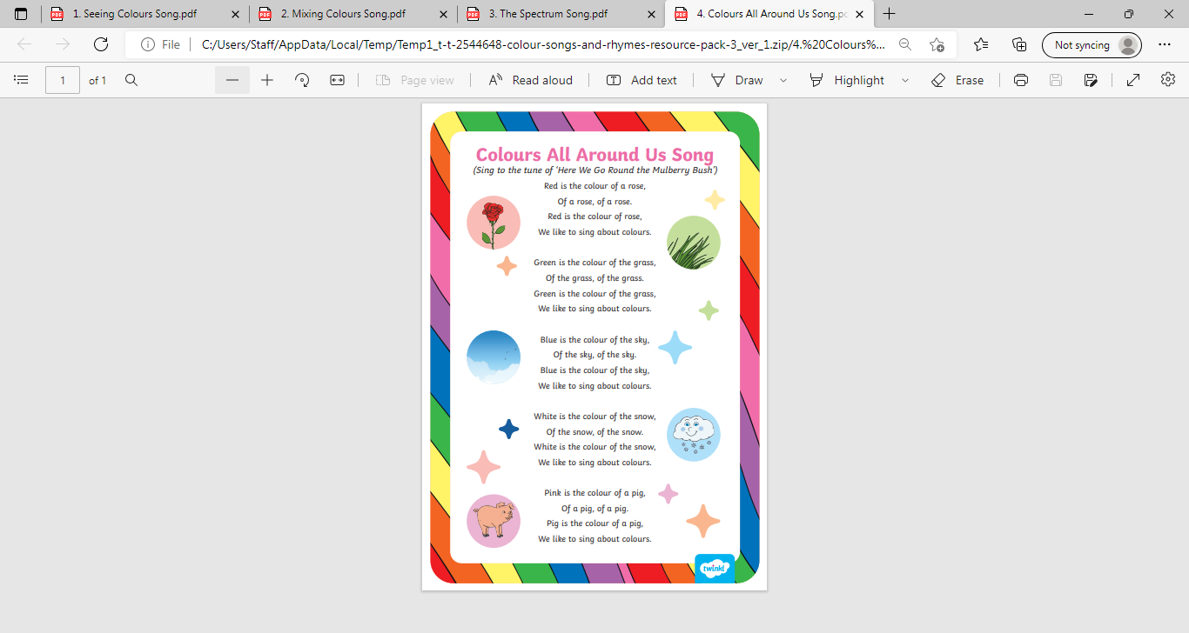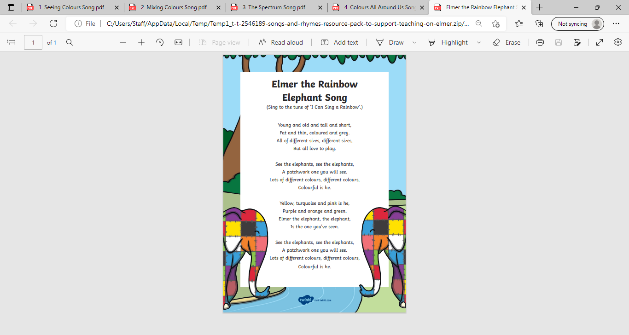
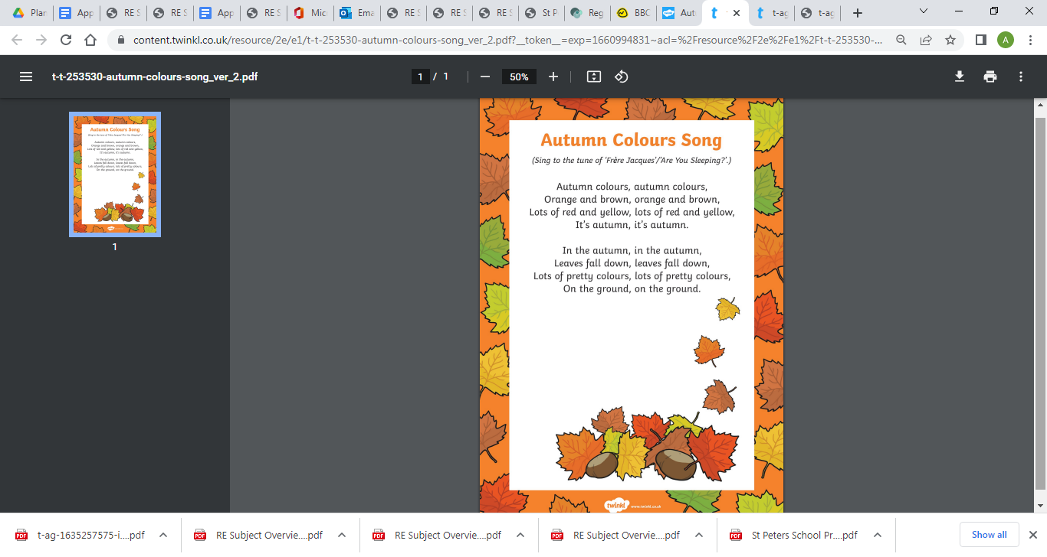
Autumn leaves
(sang in the tune of ‘London bridge is falling down’)

Autumn leaves are falling down, falling down, falling down

Autumn leaves are falling down, down to the ground.

