KS2 Science KCV – Plants
Key Knowledge | Detail
Identify and explain the function of main parts of a plant. | roots, stem/trunk, leaves and flowers
Explore the requirements of plants for life and growth. | air, light, water, nutrients from soil, and room to grow
Investigate the way in which water is transported within plants | vessels, stalk, roots, transportation
Explore the part flowers play in the life cycle of plants. | Pollination, seed formation, seed dispersal
Parts of a plant
Roots | The roots supports the plant and absorbs water and nutrients from the soil.
Stem /trunk | The stem or trunk supports the leaves and transfers water and nutrients to all parts of the plant.
Leaves | The leaf uses chlorophyll and sunlight to change carbon dioxide and water to sugar. It gives out oxygen and water.
Flowers | The flower produces seeds. It is a reproductive part of the plant. fruit The fruits disperses seeds and protects it.
Seed | The seed produces a new plant for the plant cycle to continue.

Parts of a flower
Petal | Petals are often very brightly coloured. This is because their main job is to attract insects into the flower.
Stamen | This is the male part of the flower. The anther and filament make up the stamen. It is the pollen producing part of a flower.
Anther | The anther is the part of the stamen where pollen is produced. filament The filament holds up the anther.
Pollen | This is found on the anther. The insects pick up pollen from the flower, and carry it to the next flower they visit.
Carpel | This is the female part of the flower where the seeds are made. The carpel has 3 parts: the stigma, the style, and the ovary.
Stigma | The stigma is covered in a sticky substance. Its job is to "catch" the grains of pollen (which usually come from another flower).
Style | The style is the stalk that holds up the stigma.
Ovary | The ovary contains the ovules (or "eggs").
Sepal | Sepals are special types of leaves that form a ring around the petals. Their job is to protect the flower while it is still a bud.
Receptacle | The receptacle is the top part of the flower stem, where the parts of the flower are attached. It is often rounded in shape

Key concept questions
What do plants need to grow?
What is pollination and how does it happen?
Which parts of a flower are most important?
What is the plant life cycle?

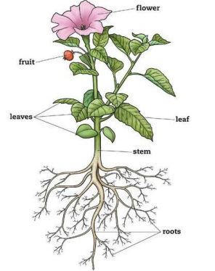

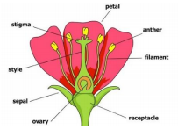

High Frequency Vocabulary
Seeds | Leaves | Plants
Flowers | Seeds | Petal
Water | Light | Food

