
Apple Tree Class
Curriculum Overview
Year A

Curriculum overview
In Apple Tree Class we are passionate about our Early Years children developing a love of learning. We strive to see every child develop into a confident and independent learner. It is our mission that every child leave Apple Tree Class with the skills to continue to flourish in KS1.
We deliver our curriculum through a balance of child-initiated and adult-led learning. We enhance the children’s environment through our planned continuous provision to support their development through their play. We encourage all children to participate in regular small group activities. The Early Years Team are highly skilled practitioners who scaffold children’s learning, giving support where needed with the aim of developing independent learners. We aim to use open ended questioning to encourage children to think for themselves.
We have planned a topic based curriculum on a two year cycle. We know that children enjoy discovering new interests through exposure to different topics and we weave children’s interests into the experiences we provide to ensure children are interested and motivated. We have given thought to the rhythms of the year, in particular seasons and festivals, and how they will impact on our children’s natural interests.
We believe that the Prime Areas of children’s learning underpin everything and place high priority on these areas, especially for our Nursery children, through planned and incidental learning. We have planned a language rich curriculum which celebrates quality books, plenty of time for talking and vocabulary that is explicitly taught.
We strongly believe that no child should be left behind and focus on every child “keeping up”, rather than “catching up”. Whether that be through additional small group interactions, 1-1 teaching, intervention programmes or specialised resources we ensure we see every child flourish.
Each day we can see the impact of our curriculum in how well the children are motivated and engaged and in the progress they are making. We are experts in being reflective and deciding what is working and what may need adjusting. We pride ourselves on how well we know each of our key children. Through ongoing interactions and formative assessments we know children’s likes, areas where they show less interest, their strengths, achievements, next steps and areas where they need further support. All of this information is fed back into our planning to ensure that children make good progress.
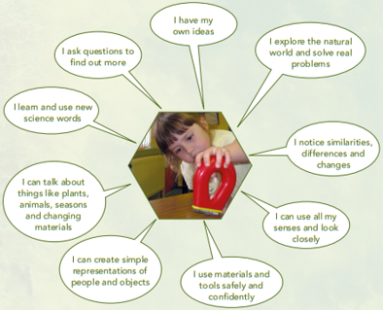

Milestone moments
We want to bring learning to life and plan trips, outings and visitors as often as possible! Each topic includes a Milestone Moment that the children will experience and each Milestone Moment links with one of our school values.

Autumn 1
Aspiration: visits from inspirational people such as firefighters, police officers, nurses and dentists.
Autumn 2
Courage: take part in a performance, inviting parents/carers to watch. Visit the theatre to watch a performance.
Peace: Visit St Peter’s church to find out why Christmas is a special time for Christians.
Spring 1
Friendship: Creating large construction vehicles and inviting friends to join you on imaginary journeys.
Respect: take part in a chinese banquet.
Spring 2
Compassion: visit a farm, interacting with various animals. Take an active role in caring for our school chickens.
Summer 1
Creativity: Visit the Story Museum and create our own stories and art based on our favourite stories.
Summer 2
Hope: Make a positive change and go litter picking.
Generosity: bake something to share with the residents at Churchfields care home.

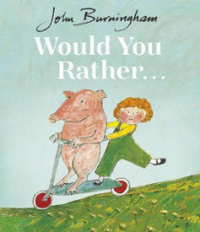
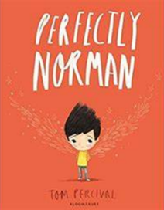
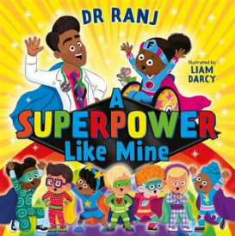
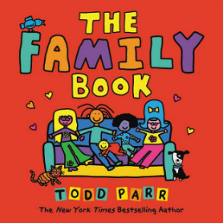

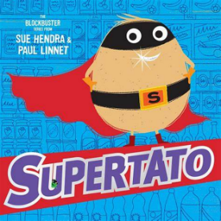
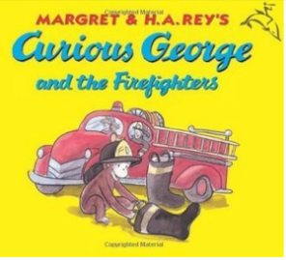
Autumn 1 - Superheroes!

Reception PSED  Learn where everything is and develop confidence and independence within the environment.  Plenty of opportunities for play with other children, including pretend play, learning to make new friends, take turns and share.  Can focus attention in a group situation for a short period of time, using seating stars to learn good listening routines. Use these opportunities to encourage talking and for children to share news and ideas.  Create a Class Charter, encouraging children to increasingly follow rules.  Introduce feelings wall, talking about feelings in simple terms, using words like ‘happy’, ‘sad’, ‘angry’ or ‘worried’. Explicitly model considering how others might be feeling.  In PSHRE, agree a class charter. Introduce each of the five keys. During the ‘Be Safe’ week work with children to identify which people can help them and how to get help when I need it. Explore good oral health (part 1 of 3). |  | Reception CL  Vocabulary explicitly taught this topic: unique, skill/talent, family, vet, librarian, dentist, teeth, decay, toothbrush, emergency, thank you  Listen to stories (see above) and remember much of what happens. Take part in discussions, asking and answering questions, including ‘why’ questions.  Use talk in their play and will start a conversation with a familiar other (adult or a friend) and continue it for many turns.  Use sentences of six words, including some conjunctions. |  | Reception PD  Move in a variety of ways. Move around the space, practising good coordination and balance when negotiating equipment and other people. Get Set 4 PE ‘Introduction to PE’ - able to balance on one leg, able to show a seated balance, able to jump in various directions and from two legs to one.  Use the trikes and scooters outside with confidence. Uses brooms to brush and spades to dig in sand and soil.  Uses one-handed tools and equipment, including lots of practise using scissors correctly.  Uses drawing equipment to draw a recognisable figure (see more in L, Drawing Club).
Nursery PSED  Learn where everything is and develop confidence and independence within the environment.  Learn the names of adults in the classroom and develop confidence to seek help when needed.  Beginning to show ‘effortful control’.  Able to put on their own coat, support to do up the zip.  Interested in the play of others and beginning to play and interact with other children and adults. |  | Nursery CL  Vocabulary explicitly taught this topic: special, different, family, teacher, dentist, teeth, decay, toothbrush, firefighter, police officer, doctor, ambulance, help, thank you |  | Nursery PD
  In a small group, listen to short stories (see above).
  Understands a range of simple instructions.
  Start to develop a conversation.
  Consistently uses sentences that link four words together.
  Can use pronouns and prepositions.
  Start to say how they are feeling, using words as well as actions.
  Can run confidently and safely.
  Can catch a large ball.
  Starting to show more balance and climbs up and down climbing equipment with more independence.
  Developing manipulation and control - moulding playdough, using a paintbrush, making marks on paper.
  Enjoys mark making and makes purposeful marks on paper.
  Enjoys movement sessions in the hall - responding to a signal.
Reception L  Enjoys listening to stories in a group (see above). | Reception M  NCETM weeks 1-5 and WRM patterns, mass and capacity.  Recites number names in order beyond ten.  Show good understanding of basic counting principles (e.g. 1-1 correspondence, knows that the amount stays the same however objects are arranged, knows the final number in the count represents how many there are).  Subitises to 3.  Compare amounts using the language of ‘more’ and ‘fewer’.  Reads numerals to 5 and matches to an amount.  Orders numbers to 5.  Recognises a repeated pattern and creates own patterns and arrangements.  Compare mass and capacity. |  | Reception UW  Describe self in positive terms, including physical characteristics, likes/preferences and skills/talents. Develop positive attitudes about the differences between people.  Names and talks about the people in their family.  Begin timeline, introducing the words ‘present’ and ‘past’. Begin thinking about the past, recognise the difference between self now and as a baby and describe an experience from the past such as a family holiday or birth of a sibling.  Find out about real life superheroes in the local community.  Talks about ways to keep our bodies healthy, including healthy foods. Baking a healthy snack - pizza!  Talk about how we change and grow over time.  Explore the seasonal changes at Forest School. Explore hibernation and learn about the animals that hibernate in England.  In RE explore the concept of “God”, “prayer” and “special”. Learn class prayers. Emphasis that everyone has different beliefs.  5 senses investigation (What’s inside?) How could we work out what’s inside without using our eyes? What others senses could we use? I notice… I wonder…  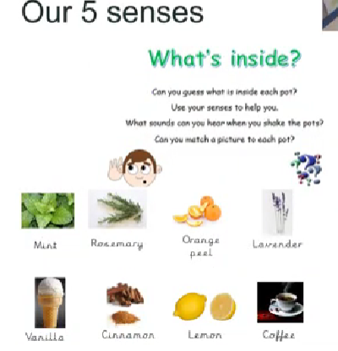 |  | Reception EAD  Learn basic skills in sticking (collage) and basic skills in colour mixing (painting) Grip, tool, hold, paint, cut, colour, mix, stick, create, creative, ideas.  Draws with increasing complexity and detail (see Drawing Club in L).  Joins in singing familiar songs and topical songs. In music enjoy exploring the different sounds we can make with our voices, bodies and musical instruments - Kapow: “Exploring Sound”  Plays imaginatively within role play and small worlds.
  Shows good phonological awareness (spots rhyming words, claps syllables, can orally blend CVC words, orally segment CVC words and orally hears initial sounds in words).
  Begins/continues their adventures in Drawing Club. Holds the pencil in a tripod grasp and uses with increasing control to draw recognisable pictures to express ideas, including representing ideas like movement, loud noises or emotions.
  Learn to write their own name correctly, holding a pencil in tripod grasp.
  Begins journey into RWI, learning Set 1 sounds.
Nursery L | Nursery M |  | Nursery UW  With prompting, talks about members of their family.  During discussions about photos, books or each other, notices differences and can comment on this (adults modelling this positively).  Notices differences between themselves now and when they were a baby.  Talks about foods that are healthy for our bodies. Baking a healthy snack - pizza!  At Forest School, shows curiosity about the natural world and enjoys exploring, commenting on what they see.  5 senses investigation (What’s inside?) I smell… I hear… I feel… I taste… I see… |  | Nursery EAD
  Enjoys sharing books with an adult (see above) and repeats words and phrases from familiar stories.
  Join in with singing times.
  Begins to notice the first letter of their name.
  Enjoys mark making activities.
  Joins in with counting songs.
  Recites numbers in order to five.
  Names colours and matches colours.
  Sorts objects by colour, size or type.
  Notice patterns, for example - stripes on clothes, designs on rugs and wallpaper. Begins to create simple patterns, with support.
  Completes peg board puzzles, matching shapes/pictures together.
  Enjoys joining in with songs and enjoys exploring the sounds different musical instruments can make.
  Use objects as representations in pretend play.
  Explores paint using fingers as well as brushes and other tools.
  Explores sticking using various materials and glue.
  Explores different sensory materials, using all their senses to investigate them.
  Makes simple models using various construction materials.

Autumn 2 - Celebrations
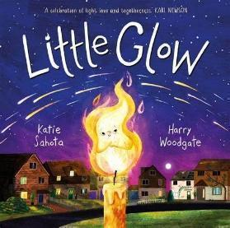

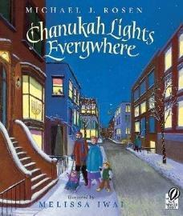
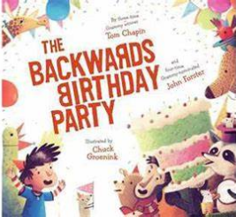
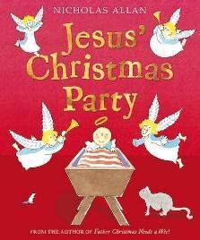
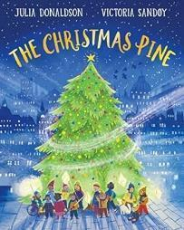

Reception PSED  Opportunities to spend extended amounts of time in an activity, showing high levels of engagement.  Can identify a wider range of feelings, e.g. scared, excited, angry, frustrated, nervous, worried and joyful.  Is willing to keep trying if something is difficult or challenging.  Makes independent choices and is confident to try new things.  Perseveres with fastenings on coats.  Is aware of the needs or feelings of others and responds appropriately when another child is upset.  Interacts with a variety of children and is building good relationships with adults and children in the class.  In PSHRE focus on the celebrating difference jigsaw piece. Discuss how we are all unique and explore similarities and differences between us. Think about how families and homes are all different and ways to be a good and kind friend. |  | Reception CL  Vocabulary explicitly taught this topic: celebration, Diwali, festival, season, Winter, daylight, ice, frost, snow, hibernation, migration, Christian, Jesus, celebrate  Listens carefully at story time, chatting about what’s been read (i.e. key points from story, characters etc).  Responds to a series of instructions and responds to a range of questions.  Contributes relevant comments during group discussions.  Uses talks to communicate needs, news, feelings and ideas.  Uses new vocabulary (see above). |  | Reception PD  Uses a range of ways to move appropriately, e.g. jumping, hopping, sliding.  Can climb over, under and through obstacles, e.g. climbing frame and large construction obstacle courses, large apparatus in PE.  Get Set 4 PE ‘Fundamentals’  Uses pens and pencils with increasing control when drawing. Consistently uses a tripod grip.  Use scissors to cut along curved lines, holding scissors correctly.  Is able to mould and shape clay with fingers and tools.
Nursery PSED  Selects and uses activities and resources, asking for help when needed.  Can wash their hands independently. |  | Nursery CL  Vocabulary explicitly taught this topic: celebration, fireworks, Diwali, lights, Winter, cold, ice, frost, snow, hat, gloves, scarf, Jesus, story, birthday, family |  | Nursery PD
  Increasingly aware of classroom routines and expectations i.e. lining up, where to put their coat, tidy up time.
  Increasingly, uses the toilet with more independence. .
  In a small group, enjoys listening to longer stories and can remember much of what happens.
  Understands and follows a simple instruction.
  Ask questions.
  Continue to develop their movement skills when balancing and riding (climbing the outside equipment and riding scooters and trikes).
  Go up steps using alternate feet.
  Enjoys movement sessions in the hall - moving in different ways in the space and enjoying moving to music. Stand on one leg and hold a pose for a game like musical statues.
  Uses scissors in one hand, making snips in paper with scissors.
  Holds pencils and pens in fingers when making marks.
Reception L  Joins in with a discussion about stories they have just listened to.  Continues their RWI journey, recognising most of the sounds in the alphabet and learning Set 1 ‘special friends’.  Can blend sounds to read a simple CVC word.  Continues their Drawing Club adventures, using the pencil with increasing control to add more detail and complexity into their masterpieces. Is able to write a ‘password’ (CVC word) to accompany their drawing.  Writes recognisable letters for most of the sounds taught, working on correct formation. | Reception M  NCETM weeks 6-10 and WRM 2D shapes.  Can subitise to 5.  Recognises numbers to 5, puts them in order and links with amounts.  Write numerals to 5.  Is beginning to talk about the different ways that amounts of 5 can be made.  Counts objects accurately to 10, showing understanding of counting principles.  Uses 2D shape names (circle, square, rectangle, triangle), finds these shapes and talks about their properties. |  | Reception UW  Knows about the celebrations of Christmas, Advent and Diwali and is able to talk about how they are celebrated.  In RE, explores the Understanding Christianity unit on incarnation.  At Forest School, make observations of plants and animals and talk about seasonal changes, describing what they noticed. Work towards our Fire Skills certificate.  Baking ‘christmas tree’ bread  Ice investigation…How can we free the animals? I see… I notice… I wonder… |  | Reception EAD  Uses the continuous and enhanced provision, making independent choices about the resources needed and talking about their creations.  Practises the printing technique, exploring the work of artist Nat Morley - layering colours, printing and then printing on top.  Hold, paint, colour, mix, print, layer, create, creative, ideas, pattern.  Sings familiar songs and moves in response to music. Kapow - “Celebration Music”. Learn Nativity songs to perform.  Plays alongside others to develop storylines in role play and small worlds.
Nursery L  Ask questions about a book.  Enjoys drawing freely, making some recognisable shapes and pictures. | Nursery Maths  Recite numbers in order to ten.  Counts a small group of objects, understanding the one-to-one and cardinal principles.  Compares two groups of objects, pointing at which has more/fewer.  Can make comparisons relating to size, using language such as big/little or small/large. |  | Nursery UW  Talks about family and things they have done recently.  Joins in with activities about different celebrations, beginning to understand that people celebrate different things/in different ways.  Continues to enjoy exploring at Forest School, using all their senses in hands-on exploration of natural materials. Talk about what they see, using a wide vocabulary.  Baking ‘christmas tree’ bread  Ice investigation play tray… I see… I notice… I wonder… |  | Nursery EAD
  Enjoys sharing books in a small group.
  Names the main characters from a familiar story.
  Develop their phonological awareness (in line with Phase 1), so that they can differentiate between sounds (e.g. a drum and a tambourine, an aeroplane and a bike) and make a quiet sound, a loud sound and copy sound patterns with their bodies.
  Explore different materials freely, making decisions about what to make.
  Sings favourite nursery rhymes. Joins in with singing Nativity songs.
  Takes part in simple, pretend play often based on familiar experiences, e.g. making dinner.

Spring 1 - Explorers
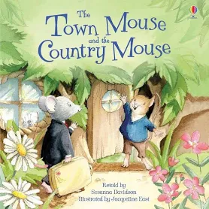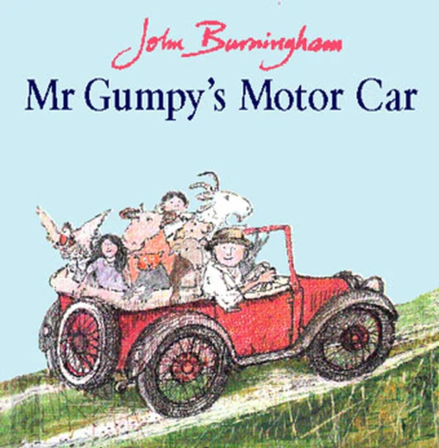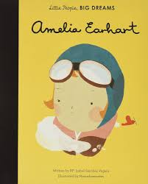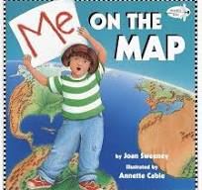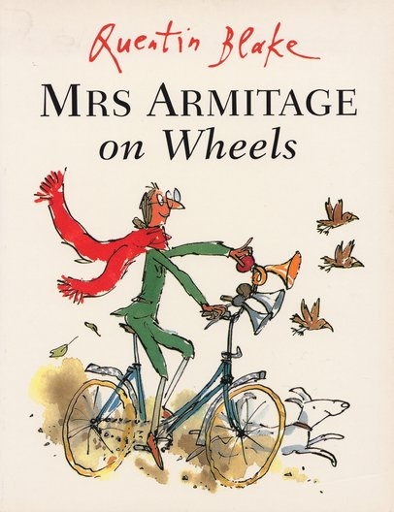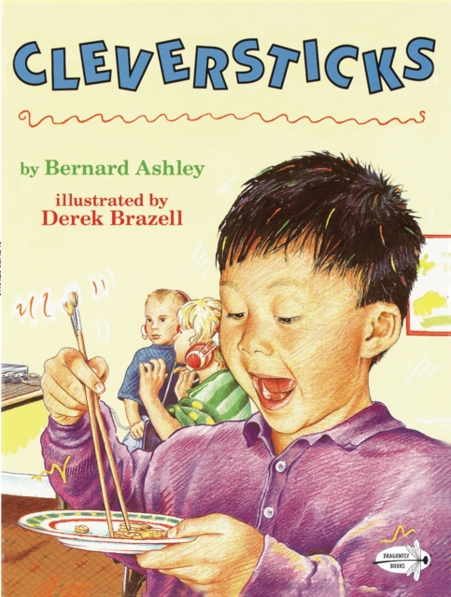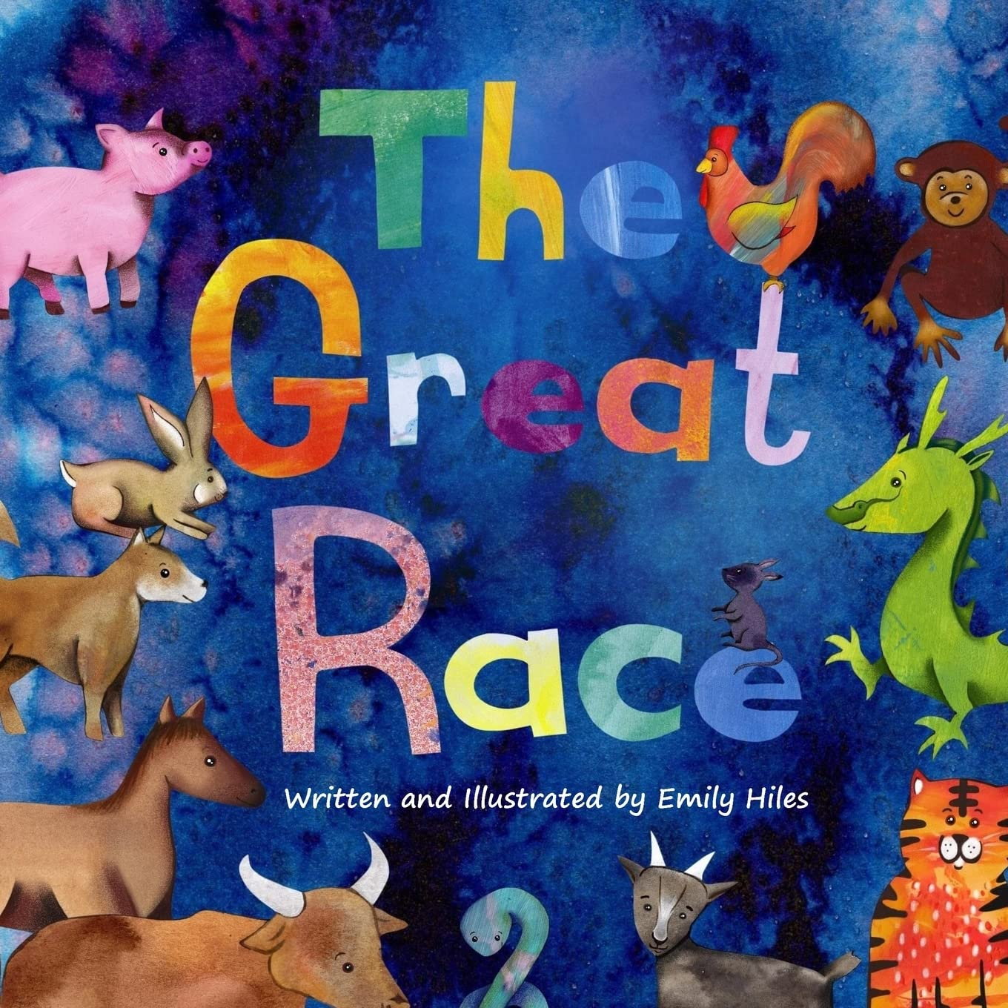

Reception PSED  Can label and talk about own and others’ emotions.  Follows school and class rules and can talk about their importance.  Can cooperate with others, listening and sharing some ideas and will listen to advice about how to solve disagreements.  In PSHRE focus on the Move Outside key. Explore why being active is good for us and the benefits of being outside. In the First Aid week discuss what an emergency is and how to get help in an emergency. In the Safer Internet week explore what safe use of technology looks like (Share advice with parents to encourage safe online use in the home). Explore good oral health (part 2 of 3). |  | Reception CL  Vocabulary explicitly taught this topic: transport, vehicle, past, present, compare, country, map, building, landmark, New Year, celebration, lantern, chopsticks.  Joins in with discussions, contributing relevant comments and questions.  Is able to listen in a larger group and recall some of the themes and comments at a later stage.  Enjoys being part of conversations and discussions and uses new vocabulary (see above) in context. |  | Reception PD  Get Set 4 PE ‘Dance’ move in response to music, move body in a variety of ways, changing in response to changes in the music, learn a sequence of movements, work alongside others and with a partner.  Is able to use scissors with control to cut with increasing accuracy to cut around more complex shapes.  Uses pens and pencils with increasing control and skill to write and draw.
Nursery PSED  Increasingly follow class rules and expectations.  Takes part in pretend play.  Can take turns and share, sometimes with adult support. |  | Nursery CL  Vocabulary explicitly taught this topic: Train, car, lorry, digger, boat, aeroplane, tractor, rocket, submarine, fire engine, bike, old, new, place, country, map, house, church, shop, New Year, lantern, chopsticks.  Use a wider range of vocabulary (see above).  Use longer sentences of five to six words.  Take part in a conversation with an adult or a friend. |  | Nursery PD  Enjoys movement sessions in the hall - moving in different ways across balancing and climbing equipment (gymnastics).  Uses a tripod grip with increasing consistency, as they use various pens and pencils.  Continues practising using scissors in one hand (thumb on top!)
Reception L  Answers questions about stories they have listened to.  Identifies non-fiction texts, remembering facts.  Confidently reads CVC words.  Writes recognisable letters, practising correct formation.  Writes CVC words and labels, using phonic knowledge.  Practises using finger spacing between words.  Continues their Drawing Club adventures, using the pencil with increasing control to add more detail and complexity into their masterpieces. Is able to write a caption to accompany their drawing. | Reception M  NCETM weeks 11-15 and WRM length and height.  Is able to compare sets and use language of comparison: more than, fewer than, an equal number to. Is able to make unequal sets equal.  Developing a sense of numbers to 10, looking at staircase models (each number being one more) and five and a bit models.  Write numerals to 10.  Uses mathematical language to compare and talk about size. |  | Reception UW  In RE explore how Chinese/Lunar New Year is celebrated. Continue to build an understanding of some similarities and differences between different religious and cultural communities in this country, drawing on their experiences and what has been read in class.  In RE share some of the stories about Jesus in the New Testament.  Talks about significant historical events and how things were different in the past, looking further back on our class timeline.  Describes a journey within the local environment.  Has a wider understanding of the wider world and draws comparisons between own local environment and other places.  Looks at and makes maps.  At Forest School, work towards our Tool Skills certificate.  Baking pancakes  Magnet investigation (have a bottle filled with feathers and pipe cleaners, use a magnet on the outside on the bottle…) I see… I notice… I wonder… |  | Reception EAD  Uses the collage technique, combining materials to create different effects/colours/textures. Is beginning to plan a design before starting. Uses a range of tools and equipment and selects the most appropriate tool or joining material for the job.  Finds out about the artist Henry Matisse (cut out paper shapes).  Grip, tool, hold, cut, layer, create, creative, ideas  Kapow - “Music and Movement”. Listens to and plays a range of instruments. Moves in response to the music, considering tempo.  Along with others, collects resources to develop own role play storylines.
Nursery L  Independently looks at books, turning the pages carefully.  Is continuing to develop their phonological awareness (in line with Phase 1), so that they can: - spot and suggest rhymes and count or clap syllables in a word.  Is able to recognise own name. | Nursery M  Continue to practise counting (show developing awareness of all the counting principles).  Practise subitising amounts to 3.  Look at numerals 1-5, linking to amounts on a five frame, spots on a dice and numicon piece. |  | Nursery UW  Joins in with activities exploring Chinese New Year, developing their understanding that people celebrate different things.  Show interest in different occupations.  Talks about the place where they live or their journey to Nursery e.g. landmarks, things they notice.  Magnetic play tray… I see… I notice… I wonder… |  | Nursery EAD  Introduction to Drawing Club where they are encouraged to enjoy making marks intentionally.  Join in with singing, expanding their repertoire of songs.  Opportunities to use various materials and glue to practise collaging.

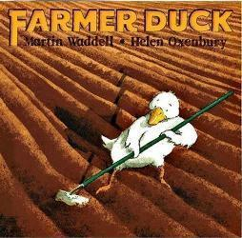
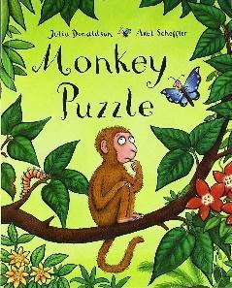
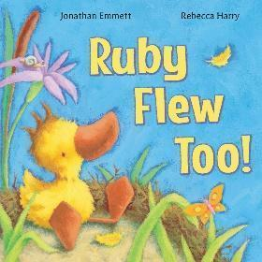
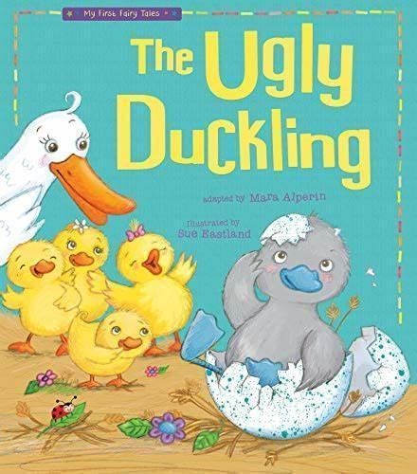
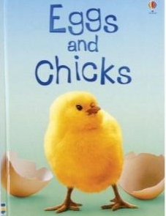
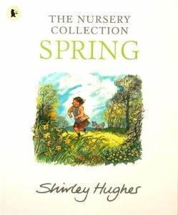
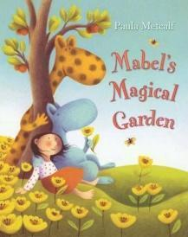
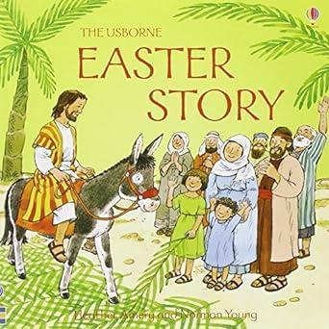
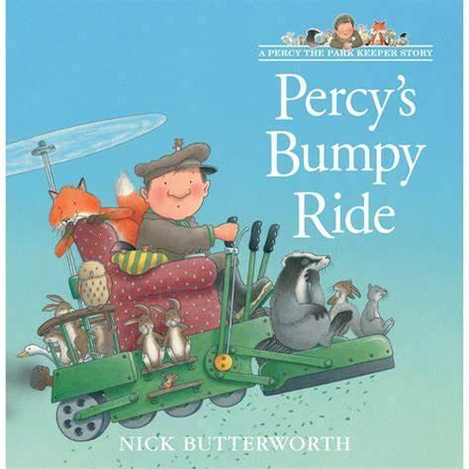
Spring 2 - Old McDonald

Reception PSED  More confident to tackle new challenges and with encouragement will keep going. Completes set challenges/tasks independently.  Is able to talk about ways that skills can be improved and to demonstrate pride in achievements.  Uses words to solve conflicts.  Takes turns in group activities.  Identifies how others feel and responds appropriately.  In PSHRE focus on the Share More key. Explore how we can use talk to help work out problems and organise our thinking, develop social phrases and continue looking at how to build constructive and respectful relationships. Talk about own family and understand that each family is different. In the Safer internet week use educational apps and platforms (Share these with parents to encourage safe online use in the home). |  | Reception CL  Vocabulary explicitly taught this topic: crops, life cycle, hatch, incubate,  Spring, bud, blossom, daffodil, crocus, seed, Easter, Christian, Jesus  Can follow complex instructions.  Responds to discussion with comments and questions.  Is able to listen in a larger group and recall some of the themes and comments at a later stage.  Enjoys being part of conversations and discussions and uses new vocabulary (see above) in context.  Uses talk in different ways, in imaginative play, to develop thinking, to collaborate and plan with others and to express ideas |  | Reception PD  Get Set 4 PE ‘Ball Skills - Develop skills and accuracy in moving and stopping a ball. Throwing and catching a ball, dribbling and kicking a ball.  Enjoys using bats and balls outside.  Uses pens and pencils effectively to write and draw.
Nursery PSED  Talk about their feelings using words like ‘happy’, ‘sad’, ‘angry’ or ‘worried’.  Uses the toilet, mostly independently, and washes hands.  Plays with one or more other children, extending and elaborating play ideas. |  | Nursery CL  Vocabulary explicitly taught this topic: farm, crops, egg, hatch, cow/calf, horse/foal, sheep/lamb, pig/piglet, chicken/chick, duck/duckling, dog/puppy, cat/kitten, Spring, bud, blossom, Easter, Jesus  Use a wider range of vocabulary (see above).  Use longer sentences of five to six words.  Can ask questions.  Uses plurals.  Enjoy listening to longer stories and making relevant comments.  Can understand simple questions about ‘who’, ‘what’ and ‘where’. |  | Nursery PD  Enjoys movement sessions in the hall - practising skills using small equipment like balls and beanbags.  May show a preference for a dominant hand.  Uses a tripod grip, further developing control when holding pens and pencils.
Reception L  Identifies non-fiction texts, remembering facts  Confidently reads CVC words.  Can read a simple sentence using their phonic knowledge.  Recognises some diagraphs.  Read a few “tricky words”.  Writes recognisable letters, many are correctly formed.  Writes CVC words, labels and captions, using phonic knowledge.  Uses finger spacing between words with some consistency.  Continues their Drawing Club adventures, using the pencil with increasing control to add more detail and complexity into their masterpieces. Is able to write a sentence to accompany their drawing. | Reception M  NCETM weeks 16-20 and WRM time and 3D shape.  Confidently talks about the different ways that numbers can be made to 5 and is now applying this knowledge to numbers to 10.  Recalls double facts to 5.  Verbally counts to 20 and is starting to recognise the pattern of the counting system to help count beyond.  Recognises patterns within numbers (e.g. noticing the pattern of odd, even, odd, even).  Uses mathematical language to compare and talk about shape. |  | Reception UW  In RE explore the Understanding Christianity unit on Salvation.  Has a good general knowledge about living things and the natural world and can name the different parts of a flower and a tree.  Can talk about the life cycle of a chick/duck and understands and uses some language related to animals, e.g. camouflage, predator, nocturnal, diurnal, hibernation.  At Forest School, plants a seed and cares for it as it grows, commenting on the changes they observe. Observes changes as the season changes, naming the new things that they see (e.g. daffodil, crocus, bud, blossom). Work towards our Rope Skills certificate.  Make crispie cakes  Animal investigation…Have sets of animals (animal dominos or animal dice) and make detailed observations and comparisons (i.e. these all have wings, these have four legs and these have two) I see… I notice… I wonder…  Create animals from tin foil… can your friends guess which animal you’ve made? |  | Reception EAD  Is beginning to plan a design before starting.  Develops skills in painting, knowing how to use and clean their brush. Learn how to mix various colours. Selects the colours they need thoughtfully. Finds out about artist Carol Gillan (friendly and humorous animal and pet paintings) and talks about her paintings.  Grip, tool, hold, paint, mark, colour, mix, create, creative, ideas, shape, pattern  In music uses Kapow - “Big Band” and explores different instruments and how to play them effectively. Uses instruments to compose own music.  Along with others, collects resources to develop own role play storylines.
Nursery L  Enjoys listening to a story in a group and comments on the events or characters.  Begin to copy some or all of their name.  Is continuing to develop their phonological awareness (in line with Phase 1), so that they can recognise words with the same initial sound.  May add some marks to their drawings, which they give meaning to. For example: ‘That says mummy.’ | Nursery M  Continue look at numerals 1-5, linking to amounts on a five frame, spots on a dice and numicon piece.  Continue subistising amounts to 3.  Explore 2D shapes, naming them and finding them in the environment. |  | Nursery UW  Names animals and their babies and learns about how things grow and change over time. Learns about the life cycle of a farm animal.  Talks about events from the past, sharing photos from when they were younger etc.  At Forest School, talks about growth and change - planting a seed and noticing how it changes, talking about things they notice as the season changes. They are beginning to understand the need to respect and care for the natural environment and all living things, being gentle with found creatures and not picking the plants and flowers.  Animal investigation tray with photos and small world play animals… can you match together ones that are the same… I see… I notice… I wonder… |  | Nursery EAD  Continued to be invited to Drawing Club. Draws with increasing detail, such as representing a face with a circle and including details.  Begins to develop complex stories using small world equipment like animal sets, dolls and dolls houses etc  Join in with singing, expanding their repertoire of songs.  Explores colour and colour mixing and enjoys painting.

Summer 1 - Once Upon a Time
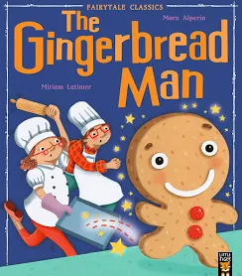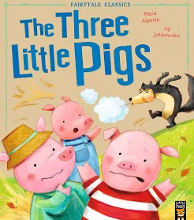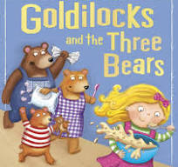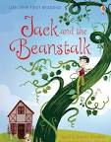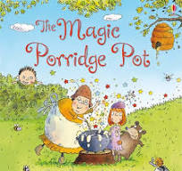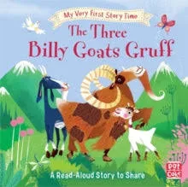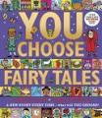

Reception PSED  Work and play cooperatively, taking turns with others.  Manage their own basic hygiene and personal needs, including dressing, going to the toilet and understanding the importance of healthy food choices.  In PSHRE focus on the Be Curious key. Encourage discussions around things they enjoy and understand that different people enjoy different things. Explore what it looks like to show resilience and perseverance in the face of challenge. The Wilder World week encourages developing a sense of responsibility as a member of the class and continues developing positive attitudes about the differences between people. Explore good oral health (part 2 of 3). |  | Reception CL  Vocabulary explicitly taught this topic: end, beginning, middle, character, story, author, illustrator, plot, blurb.  Enjoy listening to and retelling familiar stories in a group (see above).  In a group, listen attentively to conversations and respond to what they hear with relevant questions or comments and offer their own ideas into conversations. |  | Reception PD  Get Set 4 PE ‘Games’ - Can send, receive, change direction and show agility in movement. Group games - follow rules of simple group games and work with others. Manage space successfully, alongside others. Sports Day races  Use a range of small tools with skill, including scissors.  Draw and write with accuracy and care.
Nursery PSED  Enjoys spending time with adults and children in the class and plays with one or more other children, extending and elaborating play ideas.  Continues labelling feelings, thinking about how each feels on the inside and looks on the outside. |  | Nursery CL  Vocabulary explicitly taught this topic: end, beginning, middle, character, story, author, favourite.  Can start a conversation with an adult or a friend and continue it for many turns.  Will sit to listen to stories and can remember much of what happens. |  | Nursery PD  Sports Day races  Continues practising holding a pencil in a tripod grasp, which is now much more comfortable.  Uses one-handed tools, such as playdough rollers, paint brushes and scissors.
Reception L  Answer questions about stories they have listened to.  Has a good understanding of story structure and can retell and make up own stories using vocabulary that has been learnt.  Reads and writes sentences in line with their phonic knowledge, including some tricky red words.  Read their writing back to an adult.  May write some upper case letters at the start of a sentence and may finish their sentence with a full stop.  Continues their Drawing Club adventures, using the pencil with increasing control to add more detail and complexity into their masterpieces. Is able to write a sentence(s) to accompany their drawing. | Reception M  NCETM weeks 21-25 and WRM manipulate shapes.  Accurately counts larger sets and things that cannot be seen.  Continues developing confidence in exploring the composition of numbers to 10, knowing some numbers that go together to make 10.  Uses mathematical language to compare and talk about shape, space and position. |  | Reception UW  In RE share some of the Old Testament bible stories.  At Forest School, join in with planting and caring for our vegetable garden talking about what plants need. Work towards our Nature Skills certificate.  bake gingerbread men  Materials investigation - using lolly sticks and pegs can you build a house for little pigs/bridge for billy goats gruff - I see, I notice, I wonder…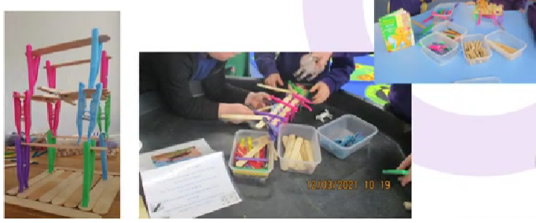 |  | Reception EAD  Find out about artist Korky Paul, a children’s illustrator who now lives in Oxford. Have a go at doing some guided drawing sessions together, developing skills in drawing.  Grip, tool, hold, mark, draw, colour, create, creative, ideas, shape, pattern  In music, use Kapow “Musical Stories” to use voice and instruments to create musical stories.  Act out familiar stories using story language.  Learn to do a running stitch to create a bookmark.
Nursery L  Enjoys listening to stories in a group and can retell a simple story using visual clues, e.g. talking through a familiar book.  Joins in with a range of familiar rhymes and songs.  Shows a developing phonological awareness: has a developing ability to spot rhyming words, count or clap syllables in a word, recognise words with the same initial sound. | Nursery M  Sequence events in their day.  Talk about and compare length and height. Children can find objects that are longer/shorter than a given item and compare them by placing them side by side.  Notice and describe 3D ‘solid’ shapes in the environment and talk about the properties using words such as ‘straight/flat/round/curved’. |  | Nursery UW  Describes a personal experience from the past such as a family holiday, birth of a sibling etc.  At Forest School talks about the things that are noticed, particularly thinking about the plants we are growing and how they are changing. Enjoys helping to care for the vegetable garden.  Materials investigation, using construction, can you build a house for the little pig/a bridge for billy goat gruff - I see… I notice… I wonder… |  | Nursery EAD  Continues to be invited to Drawing Club.  Takes part in guided drawing with an adult, adding more details into their pictures.  Joins in singing familiar songs.  Uses role play and small world resources, sometimes playing with others to develop storylines.

Summer 2 - Under the Sea
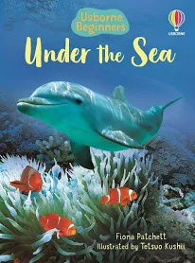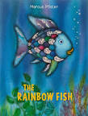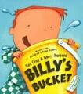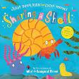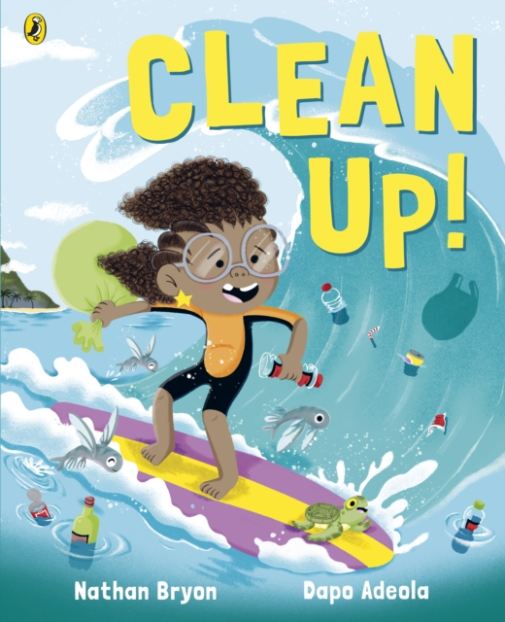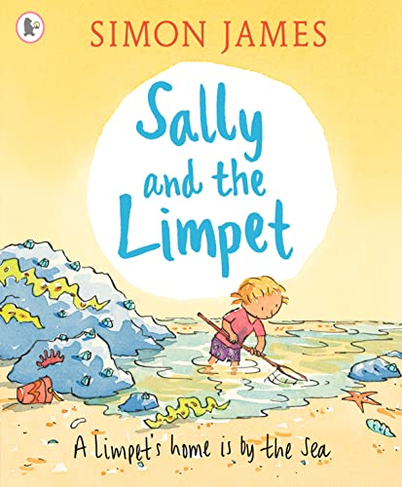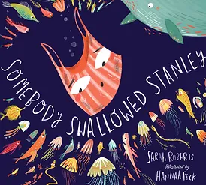

Reception PSED  Show an understanding of their own feelings and those of others, and regulate their behaviour accordingly.  Be confident to try new activities and show independence, resilience and perseverance in the face of challenge.  Explain the reasons for rules, know right from wrong and try to behave accordingly.  In PSHRE focus on the Be Kind key. Explore how to be kind to yourself and to others and consider the feelings of others. In the NSPCC weeks explore who to tell if feeling uncomfortable, upset or unsafe. Talk about the pants rule and what privacy means and which body parts are private. Talk about when a secret should not be kept but told to a trusted adult. In the Be Safe week explore the different factors that support health and wellbeing: regular physical activity, healthy eating, toothbrushing, good sleep routines, how to cross a road safely and sensible amounts of screen time. |  | Reception CL  Vocabulary explicitly taught this topic: sea, ocean, squid, coral, anemone, plastic, pollution, protect, beach, rockpool, limpet.  Express their ideas and feelings about their experiences using full sentences, including use of tenses and conjunctions.  Hold conversations that continue back-and-forth for many exchanges. |  | Reception PD  Get Set 4 PE ‘Gymnastics’ - move in a variety of ways on and off apparatus/equipment, show balance, complete sequences of movement, demonstrate core strength.  Move energetically, such as running, jumping, dancing, hopping, skipping and climbing. Demonstrate coordination, strength and balance.  Use a range of small tools with skill, including scissors.  Draw and write with accuracy and care.
Nursery PSED  Talks about their feelings in simple terms, using words like ‘happy’, ‘sad’, ‘angry’ or ‘worried’. May show some understanding of how others might be feeling.  Reliably toilet trained, using the toilet independently. |  | Nursery CL  Vocabulary explicitly taught this topic: sea, ocean, fish, shark, whale, crab, octopus, plastic, litter, protect, beach, rockpool, limpet.  Can use sentences of six words, including conjunctions.  Understands a question or instruction that has two parts. |  | Nursery PD  Holds pencil in a comfortable tripod grasp and uses one-handed tools, such as playdough rollers, paint brushes and scissors.  Can use scissors to cut, holding scissors in one hand with their thumb on top!  Enjoys movement sessions in the hall - moving in lots of different ways and showing different balances. Practises skills using a ball - throwing, catching, bouncing and kicking. Has good coordination and balance when negotiating equipment and other people
Reception L  Demonstrate understanding of what has been read by retelling stories and describing facts in their own words and using recently introduced vocabulary.  Write simple phrases and sentences that can be read by themselves and others. Read aloud simple sentences and books that are consistent with their phonic knowledge, including some tricky ‘red’ words and words with diagraphs from Set 1 and Set 2.  Continues their Drawing Club adventures, using the pencil with increasing control to add more detail and complexity into their masterpieces. Is able to write sentences to accompany their drawing. | Reception M  NCETM weeks 26-review and assess weeks and WRM numbers beyond 10.  Has a deep understanding of numbers to 10, including the composition of each number.  Uses a range of mathematical language to describe and compare size, shape, length, weight and position.  Explores patterns within numbers up to 10, including evens and odds, double facts and how quantities can be distributed equally.  Automatically recalls number bonds up to 5 (including subtraction facts) and some number bonds to 10, including double facts.  Begins to explore numbers to 20, using tens frames. |  | Reception UW  Explore the natural world around them during Forest School sessions, name and draw the plants and animals found, making detailed observations. Work towards our Den Skills certificate.  Explore some similarities and differences between this country and other countries, particularly considering animals that live in the seas, drawing on knowledge from stories and non-fiction texts.  Consider how we can care for our natural world, discussing litter and recycling.  In RE explore the Understanding Christianity unit on ‘Creation’.  chop fruit and vegetables to create fruit kebabs and soup  Understand some important processes in the natural world around them – exploring floating and sinking. Floating and sinking investigation… I see… I notice… I wonder… |  | Reception EAD  Safely use tools to join a variety of materials 3D sculptures (junk modelling)  Artist - TC Trash Art  (could also look at Robert Bradford)  Grip, hold, stick, 3D, layer, create, creative, ideas, shape, pattern  Share their creations, explaining the process they have used.  Invent, adapt and recount narratives and stories with peers and their teacher  Perform poems.
Nursery L  Can orally blend some simple CVC words.  Can orally segment some CVC words and orally hears initial sounds in words.  Write some or all of their first name. | Nursery M  Children respond to position and directional language and begin using these words themselves.  Children explore weight and capacity through hands-on exploration and use the language full/empty, heavy/light.  Shows good understanding of basic counting principles (e.g. 1-1 correspondence, knows that the amount stays the same however objects are arranged, knows the final number in the count represents how many there are).  Subitises to 3 (may recognise dice patterns beyond this). |  | Nursery UW  Talks about the world and experiences they have of seeing the sea!  Names animals that live in the sea.  Enjoy water play, observing how different objects behave differently in the water! Talk about those that float and those that sink. I see… I notice… I wonder…  At Forest School uses all their senses to explore the natural world and talk about the things that are noticed. Enjoys hunting for minibeasts! |  | Nursery EAD  Continues to be invited to Drawing Club. Draws with increasing detail and uses drawing to represent ideas like movement, loud noises or emotions.  Joins in singing familiar songs.  Explores colour and colour mixing.

